**CAN THO UNIVERSITY**

**COLLEGE OF INFORMATION AND COMMUNICATION TECHNOLOGY DEPARTMENT OF INFORMATION TECHNOLOGY**

🙞 🕮 🙜



**BASIC THESIS**

**OF ENGINEERING IN**

**INFORMATION TECHNOLOGY**

**(HIGH-QUALITY PROGRAM)**

**BUILDING AN ONLINE SHOPPING WEBSITE**

**FOR THE BOOKSTORE**

**Student: Khúc Bảo Minh**

**Student ID: B2105709**

**Class: 2023-2024 (Cohort K47)**

**Advisor: Dr. Trương Minh Thái**

**Cần Thơ, 04/2024**

**ACKNOWLEDGMENT**

I would like to express my sincere gratitude to the following individuals fortheir invaluable support and contributions throughout the development of this report:

Dr. Truong Minh Thai, my basic thesis supervisor, guided, suggested, and provided valuable knowledge throughout the research process. My family and friends, for their unwavering support and encouragement throughout my studies.

I am truly grateful for the help and support of my lecturers, family, and friends. in this project. Their contribution is the driving force to complete it.

**ABSTRACT**

The purpose of the thesis “Building an online shopping website for the bookstore.” To build and develop an online shopping website for a bookstore. The website is designed to provide users with a convenient and enjoyable shopping experience while enhancing the efficiency of the online bookstore.

For the software, we utilized modern technologies such as HTML, CSS, JavaScript, and PHP to create a user-friendly interface and powerful features for enhancing user experience when visiting the website.

Throughout this process, we focused on improving the user experience and optimizing the shopping functionality on the website. In doing so, we hope that our website will attract and retain many customers, thereby increasing sales and enhancing the reputation of the online bookstore.

**CONTENTS**

I. PROBLEM STATEMENT INTRODUCTION 6

1.INTRODUCTION TO THE THESIS 6

2. RELATED STUDY 6

3. PURPOSE 6

4. SUBJECT AND SCOPE OF THE THESIS 7

5. RESEARCH METHOD 7

6. STRUCTURE OF THE BASIC THESIS 8

II. SOFTWARE REQUIREMENT AND APPLIED TECHNOLOGY 8

1.APPLIED TECHNOLOGY 8

1.1. HTML/CSS 8

1.2. JAVASCRIPTS 8

1.3. PHP 8

1.4. MYSQL 9

1.5. XAMPP 9

2. OFTWARE REQUIREMENT 9

2.1. MAIN FUNCTION OF THE SYSTEM 9

2.2. REQUIRE FUNCTIONALITY 10

2.3. FUNCTIONAL REQUIREMENT 10

2.3.1. USE CASE 10

2.3.2. View Product Use Case 11

2.3.3. Registration Use Case 13

2.3.4. Login Use Case 14

2.3.5. Search Product Use Case 15

2.3.6. Add To Cart Use Case 16

2.3.7. Payment Use Case 17

2.3.8. Product Management Use Case 18

III. SOLUTION 19

1.DATA DESIGN 19

1.1. CONCEPTUAL DATA MODEL 19

1.2. LOGICAL DATA MODEL 20

1.3. PHYSICAL DATA MODEL 20

2.DATA DICTIONARY 21

3.FUNCTIONAL DECOMPOSITION DIAGRAM 23

4.DETAIL DESIGN 23

4.1. Product Management 23

4.1.1. View Product List 24

4.1.2. Add New Product 25

4.1.3. Update Product Quantity 26

4.1.4. Delete Product 27

4.2. User Management 27

4.2.1. Registration 30

4.2.2. Log In 31

4.2.3. Update and View Personal Information 31

4.2.3.1. User Functional Navigation 31

4.2.3.2. Update Personal Information 32

4.2.3.3. View Personal Information 33

4.2.4. View Purchase History 33

4.3. Search and Browse Products 34

4.3.1. Search for Products 34

4.3.2. View Product Detail 35

4.3.3. View Product Categories 36

4.4. Cart Management and Check Out 37

4.4.1. Add to Cart 37

4.4.2. View And Edit Cart 38

4.4.3. Check Out 39

IV. CONCLUSION 39

**LIST OF FIGURES**

Figure 2. Registration Use Case 13

Figure 3. Login Use Case 14

Figure 4. Search Product Use Case 15

Figure 5. Add to Cart Use Case 16

Figure 6. Payment Use Case 17

Figure 7.Product Management Use Case 18

Figure 8. CDM 19

Figure 9. LDM 20

Figure 10. PDM 20

Figure 11. Functional Decomposition Diagram 23

Figure 12. Admin Interface 23

Figure 13. View Product Interface 24

Figure 14. Add Product Interface 25

Figure 15.Update Quantity Interface 26

Figure 16. Delete Product Interface 27

Figure 17. Before Login Interface 28

Figure 18. After Login Interface 29

Figure 19. Register Interface 30

Figure 20. Login Interface 31

Figure 21. Navigation Interface 31

Figure 22. Login Interface 32

Figure 23. Login Interface 33

Figure 24. View Purchase History Interface (Before Payment) 33

Figure 25. View Purchase History Interface (After Payment) 34

Figure 26. search Interface 34

Figure 28. Categories Interface (Before Login) 36

Figure 29. Categories Interface (After Login) 36

Figure 30. Minicart interface (No Product) 37

Figure 31. Minicart interface (Have Product) 37

Figure 32. Cart interface 38

Figure 33. Payment 39

Figure 34. After Payment 39

# I. PROBLEM STATEMENT INTRODUCTION

## INTRODUCTION TO THE THESIS

The advent of e-commerce has revolutionized the way people shop, and the book industry is no exception. In this digital age, online shopping websites have become a crucial platform for bookstores to reach a wider audience and provide customers with convenient access to a vast array of books.

The purpose of this project is to develop an online shopping website specifically tailored for a bookstore. This website aims to bridge the gap between traditional brick-and-mortar bookstores and the online world, offering customers the ability to browse, purchase, and receive books from the comfort of their own homes.

By creating a user-friendly and feature-rich online platform, we aim to address several challenges faced by traditional bookstores, such as limited physical space, geographical constraints, and the need to adapt to changing consumer preferences. Additionally, we seek to capitalize on the growing trend of online shopping by providing a seamless and enjoyable experience for book enthusiasts.

Through this project, we hope to contribute to the modernization of bookstore operations and the promotion of literacy and reading culture in the digital age.

## 2. RELATED STUDY

Previous research has emphasized the importance of user experience in online shopping, including factors like website design, navigation, and checkout process. Integrating social features and personalized recommendations can enhance engagement. Mobile optimization is crucial due to increased smartphone usage. Various marketing strategies, from SEO to content marketing, are effective in promoting online bookstore websites. Overall, these studies provide valuable insights for developing an effective online shopping platform for a bookstore.

## 3. PURPOSE

The purpose of this project is to develop an efficient and user-friendly online shopping platform tailored specifically for a bookstore. This platform aims to:

+ Provide customers with a convenient and enjoyable shopping experience.

+ Bridge the gap between traditional brick-and-mortar bookstores and the online world.

+ Increase the bookstore's reach by catering to a wider audience through the internet.

+ Optimize bookstore operations and enhance customer satisfaction through effective website design and functionality.

+ Promote literacy and reading culture by making a diverse range of books easily accessible to all.

Through the development of this online shopping platform, we aim to contribute to the modernization of bookstore operations, promote the joy of reading, and meet the evolving needs of customers in the digital age.

## 4. SUBJECT AND SCOPE OF THE THESIS

The subject of this thesis is the development of an online shopping website tailored specifically for a bookstore. The scope of the thesis includes:

+ Researching and analyzing customer requirements for an online bookstore.

+ Designing a user-friendly interface for the website, including features such as book browsing, search functionality, and secure checkout.

+ Developing the website using modern technologies such as HTML, CSS, JavaScript, and PHP.

+ Implementing social features and personalized recommendations to enhance user engagement.

+ Optimizing the website for mobile devices to ensure a seamless browsing and purchasing experience.

+ Testing the website for usability, functionality, and security.

+ Evaluating the effectiveness of the website in improving customer satisfaction and increasing bookstore sales.

The thesis will focus on the technical development of the online shopping website, as well as its impact on bookstore operations and customer experience. It aims to provide valuable insights into creating an effective online platform for selling books and contributing to the modernization of bookstore businesses.

## 5. RESEARCH METHOD

The research method for this thesis will combine qualitative and quantitative approaches to gather comprehensive insights into customer needs and preferences. Surveys and interviews will be conducted to understand customer behavior and expectations regarding online bookstores. Usability testing will provide valuable feedback on the website's design and functionality. Data analysis will be used to identify trends and patterns from the gathered data. Additionally, a comparative analysis of existing online bookstores will be conducted to identify best practices and areas for improvement. Finally, performance evaluation will ensure the website operates optimally. These methods aim to provide a thorough understanding of customer needs and assess the effectiveness of the developed online shopping website.

## 6. STRUCTURE OF THE BASIC THESIS

The basic thesis will be structured as follows: Introduction, Literature Review, Methodology, Development, Results and Analysis, Conclusion, and References. It will begin with an Introduction providing the background and significance of the study, followed by a Literature Review discussing online shopping trends and bookstore industry analysis. Methodology will explain the research methods used. Development will describe the process of creating the online shopping website. Results and Analysis will present findings, while Conclusion will summarize key points and provide recommendations.

# II. SOFTWARE REQUIREMENT AND APPLIED TECHNOLOGY

## APPLIED TECHNOLOGY

### HTML/CSS

In the age of technology, websites are ubiquitous on the internet, and behind these websites lies a familiar duo for coders: HTML and CSS. These languages work together to create the structure and style of web pages.

It can be said that HTML is the backbone of a website. It is a markup language designed for creating web pages and helps define the content and structure of the page, using tags to help the browser determine which elements are present.

CSS is the face of a website. It defines the visual style of HTML elements, adding things like color, font size, layout, and animations. It is used to style websites, making them more attractive to users.

### JAVASCRIPTS

JavaScript is a programming language used to create interactive and dynamic web pages. It is a core part of the World Wide Web, alongside HTML and CSS.

JavaScript is often used to add interactive effects to websites such as drop-down menus, animations, and simple games. It is also used to process user input and respond accordingly, communicate with APIs, and be used to create complex web pages.

With its advantages of being easy to learn thanks to its simple and easy-to understand syntax, being flexible in creating various types of applications, and its popularity, JavaScript is considered a good language to start with.

### PHP

PHP is a form of code, or a series of scripting languages used to develop web applications that run on servers. When PHP programmers write programs, the command sequence will be processed on the server, and then HTML code will be generated on the client. Based on that, applications on the website will operate easily.

It is often used in building and developing websites because it can be easily connected to other websites that use HTML. PHP is also an open-source programming language, compatible with many different platforms such as MacOS, Linux, Windows, ...

The PHP programming language often focuses on setting up server programs, creating databases, building website content, and receiving cookie data. Not only that, it can also perform many other operations and functions such as Setting up programs for the server system, Creating script lines, and Building working applications, ...

### MYSQL

MySQL is a popular and powerful open-source database management system, developed in the 1990s and operating based on the client-server model. It is an important software in managing and storing data for applications and websites.

This open-source database management system uses SQL query language and manages data through databases with multiple relational tables, creating a flexible system structure for storage. and information retrieval. Stability, open-source code, and customization are the outstanding advantages of MySQL, giving users the freedom to be creative and adapt to their specific needs.

### XAMPP

XAMPP is a free and open-source software package that allows you to easily set up a development environment to build websites on your local computer. By bundling these essential components together, XAMPP makes it easy for developers to get started with building websites locally without needing to install and configure each component individually. This is especially convenient for testing and development purposes before deploying a website to a live server.

## SOFTWARE REQUIREMENT

### MAIN FUNCTION OF THE SYSTEM

* **View Product:** Guests and Customers can view all the books displayed on the website interface.
* **Search Product:** Guests and customers can enter the book's name in the search bar to find and purchase the books they like.
* **Register:** Guests can register an account on the website to become a customer.
* **Login:** After registering an account, guests can log in to the website to access its functionalities.
* **Personal Page:** In personal page, customers can update their personal information.
* **Book Management:** If users log in with admin privileges, they can add books to the database, update quantities, view remaining stock of books, and delete books that are no longer for sale.
* **Add To Cart:** After logging in to the website, customers can choose products and add them to their cart. If they decide not to buy, they can remove them from the cart. Otherwise, they can proceed to payment.
* **Payment:** Customers can pay for the products they have chosen, and afterwards, they can view their purchase history in their personal page.

### REQUIRE FUNCTIONALITY

* The system meets product requirements:
  + Achieving efficiency in speed: The time needed to look up information is no more than 10 seconds. The time required to update data is no more than 5 seconds.
  + Flexible: convenient for system development.
* The system meets organizational requirements:
  + Simple interface, easy to use.
  + Font: Use Vietnamese font, Unicode standard.
* The system meets security requirements:
  + The system will assign rights to the user. All rights in the system will be allowed to access some necessary functions and information.

### FUNCTIONAL REQUIREMENT

#### USE CASE

#### View Product Use Case

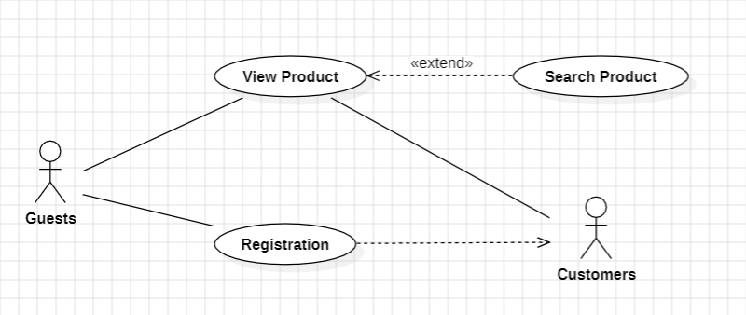Figure 1. View Product Use Case

|  |  |
| --- | --- |
| **Use case:** View Product Use Case | **ID:** UC1 |
| **Main actor:** Guest, Customer | **Priority:** 1 |
| **Brief description:** This use case outlines the process by which users access a website to view products, search for items, and register as customers. | |
| **Trigger:** None.  **Type:** External. | |
| **Relationship:**  **+ Association:** View Product, Registration.  **+ Include:** None.  **+ Extend:** Search Product.  **+ Generalization:** None. | |
| **Normal flow:**  1. Users access the website from a web browser.  2. Users can view products displayed on the homepage.  3. Users can search for products.  4. Users can click on a searched product to view details.  5. Users can become customers of the website by registering.  6. The system will change the user's status from "Guest" to "Customer". | |
| **Alternative/ Exceptional flow:**  1. In the registration step, if the user tries to create an account that already exists, an error message will be displayed, prompting them to try again. | |

#### Registration Use Case

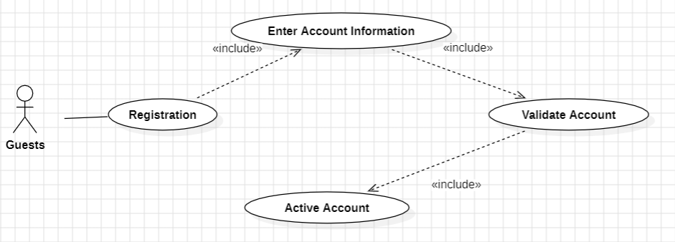

Figure 2. Registration Use Case

|  |  |
| --- | --- |
| **Use case:** Registration | **ID:** UC2 |
| **Main actor:** Guest | **Priority:** 1 |
| **Brief description:** This use case outlines the process by which a customer registers for an account on the website. | |
| **Trigger:** None.  **Type:** External. | |
| **Relationship:**  **+ Association:** Registration.  **+ Include:** Enter Account Information, Validate Account, Active Account.  **+ Extend:** None.  **+ Generalization:** None. | |
| **Normal flow:**  1. The customer is redirected to the registration page.  2. The website displays the interface for the customer to register an account.  3. The customer enters personal information, including username, password, and password confirmation.  4. The customer confirms the information.  5. The system verifies if the account information is valid.  6. The customer is directed to the login page. | |
| **Alternative/ Exceptional flow:**  1. In the registration step, if the user tries to create an account that already exists, an error message will be displayed, prompting them to try again.  2. If the website encounters an error, it sends an error message and requests the customer to try again later. | |

#### Login Use Case

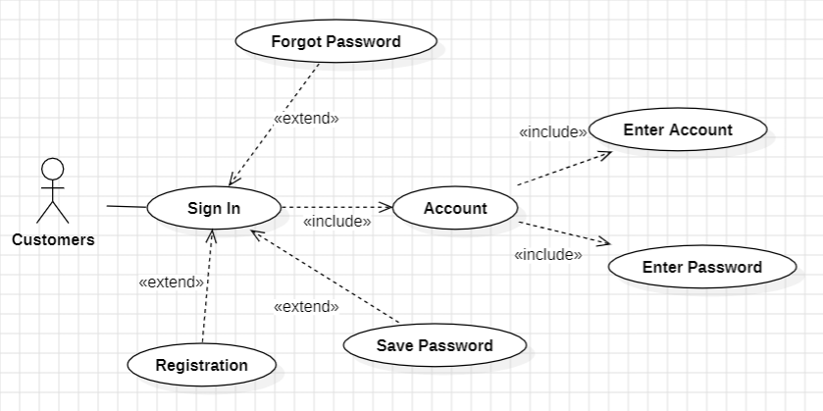

Figure 3. Login Use Case

|  |  |
| --- | --- |
| **Use case:** Sign In | **ID:** UC3 |
| **Main actor:** Customer | **Priority:** 1 |
| **Brief description:** This use case describes the process by which a customer logs into the system. | |
| **Trigger:** None.  **Type:** External. | |
| **Relationship:**  **+ Association:** Sign In.  **+ Include:** Enter Account, Enter Password, Account.  **+ Extend:** Registration, Save Password, Forgot Password.  **+ Generalization:** None. | |
| **Normal flow:**  1. Customers are directed to the login page.  2. Users enter their username and password.  3. The system verifies the user's information.  4. If the information entered by the user is correct, they will be granted access to the website.  5. Users can choose to save their password.  6. If users forget their password, they can select the forgot password option.  7. Users will be directed to the page to reset their password. | |
| **Alternative/ Exceptional flow:**  1. If the user enters an incorrect username or password that is registered, the system will display an error message and prompt the user to try again.  2. If the website encounters an error, it sends an error message and requests the customer to try again later. | |

#### Search Product Use Case

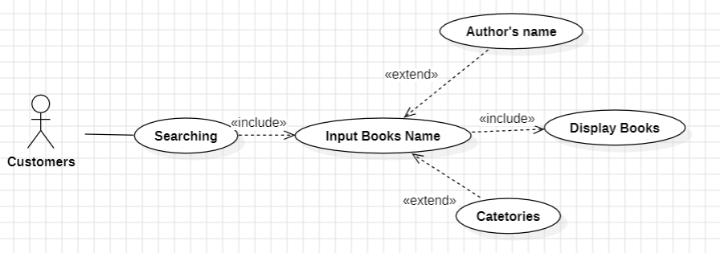

Figure 4. Search Product Use Case

|  |  |
| --- | --- |
| **Use case:** Search Product | **ID:** UC4 |
| **Main actor:** Customer | **Priority:** 1 |
| **Brief description:** This use case describes how a customer searches for books by entering book titles, authors, or genres. The system then displays related books. | |
| **Trigger:** None.  **Type:** External. | |
| **Relationship:**  **+ Association:** Searching.  **+ Include:** Input Book Name, Display Books.  **+ Extend:** Author’s name, Categories.  **+ Generalization:** None. | |
| **Normal flow:**  1. Customers access the search bar of the website.  2. Customers enter the book title, author's name, or genre into the search bar.  3. The system processes customer queries and displays relevant products. | |
| **Alternative/ Exceptional flow:**  1. If the information entered by the customer is invalid, the system will not display any products.  2. If the website encounters an error, it sends an error message and requests the customer to try again later. | |

#### Add To Cart Use Case

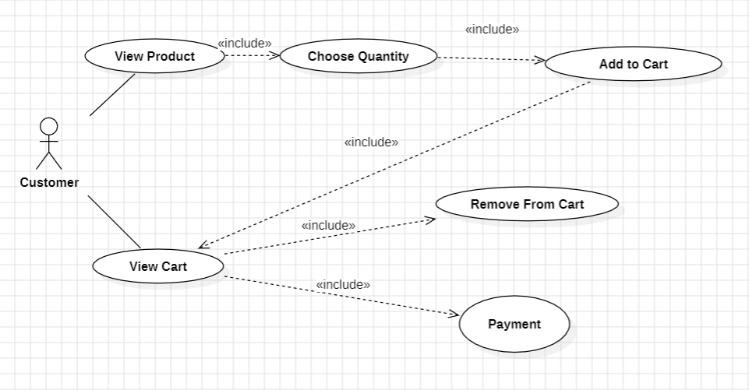

Figure 5. Add to Cart Use Case

|  |  |
| --- | --- |
| **Use case:** Add to Cart | **ID:** UC5 |
| **Main actor:** Customer | **Priority:** 1 |
| **Brief description:** When customers find their favorite product, they can choose to add it to their shopping cart. Additionally, customers can view the products in their shopping cart to adjust, such as editing or removing items, or proceed to checkout. | |
| **Trigger:** None.  **Type:** External. | |
| **Relationship:**  **+ Association:** View Product, View Cart.  **+ Include:** Choose Quantity, Add to Cart, View Cart, Remove from Cart, Payment.  **+ Extend:** None.  **+ Generalization:** None. | |
| **Normal flow:**  1. Customers select their favorite product.  2. They choose the quantity of the product they want to buy and add it to their shopping cart.  3. Customers can view the products they've added to the shopping cart.  4. They can delete products that have been added to the shopping cart.  5. Customers are directed to the checkout page. | |
| **Alternative/ Exceptional flow:**  1. The system will confirm whether the product is in stock or not. If the product is out of stock, the website will display an error message informing the customer that the product is out of stock.  2. If the customer tries to add a quantity greater than the current available stock to the shopping cart, an error message will be displayed, requesting the customer to try again.  3. If the website encounters an error, it sends an error message and requests the customer to try again later. | |

#### Payment Use Case

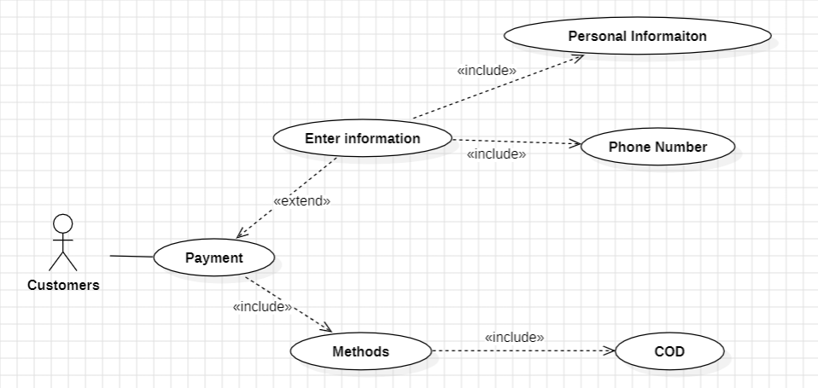

Figure 6. Payment Use Case

|  |  |
| --- | --- |
| **Use case:** Payment | **ID:** UC6 |
| **Main actor:** Customer | **Priority:** 1 |
| **Brief description:** Customer Checkout Process for Previously Added Products in the Shopping Cart. | |
| **Trigger:** None.  **Type:** External. | |
| **Relationship:**  **+ Association:** Payment.  **+ Include:** Personal Information, Phone Number, Methods, COD.  **+ Extend:** Enter Information.  **+ Generalization:** None. | |
| **Normal flow:**  1. The customer is redirected to the checkout page from the shopping cart.  2. The customer enters personal information.  3. The customer may verify their phone number.  4. The customer confirms the shipping address.  5. The customer can choose a payment method. | |
| **Alternative/ Exceptional flow:**  1. If the customer does not enter the correct email format or phone number, an error will be reported.  2. If the website encounters an error, it sends an error message and requests the customer to try again later. | |

#### Product Management Use Case

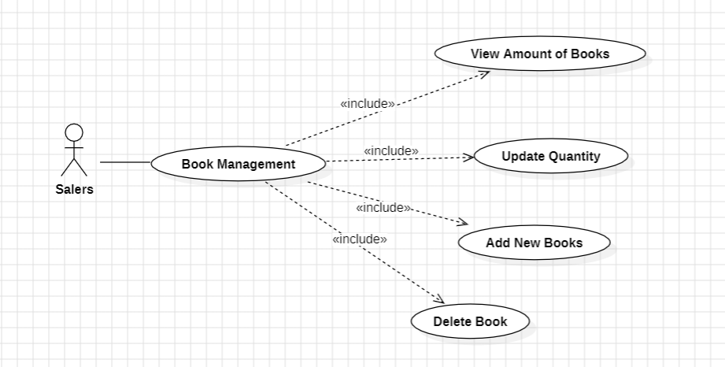

Figure 7.Product Management Use Case

|  |  |
| --- | --- |
| **Use case:** Product Management | **ID:** UC7 |
| **Main actor:** Sale | **Priority:** 1 |
| **Brief description:** The Use Case a description of how a salesperson adds a new product to the database, updates the inventory of books, views detailed information about a book, and deletes books that are no longer for sale | |
| **Trigger:** None.  **Type:** External. | |
| **Relationship:**  **+ Association:** Book Management.  **+ Include:** View Amount of Books, Update Quantity, Add new Book, Delete Book.  **+ Extend:** None.  **+ Generalization:** None. | |
| **Normal flow:**  1. The salesperson will access the website.  2. The salesperson will be able to see the remaining quantity of that type of book in stock.  3. The salesperson can update the quantity of books displayed on the website.  4. The salesperson can add a new type of book.  5. The salesperson can delete a book. | |
| **Alternative/ Exceptional flow:**  1. If the website encounters an error, it sends an error message and requests the customer to try again later. | |

# III. SOLUTION

## DATA DESIGN

### CONCEPTUAL DATA MODEL

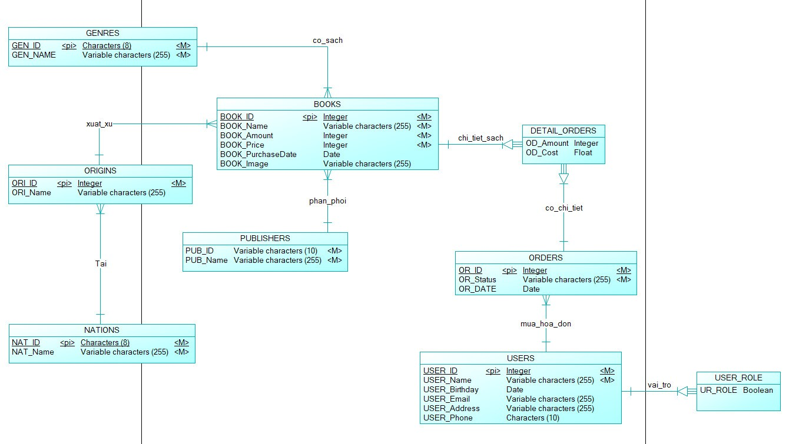

Figure 8. CDM

### LOGICAL DATA MODEL

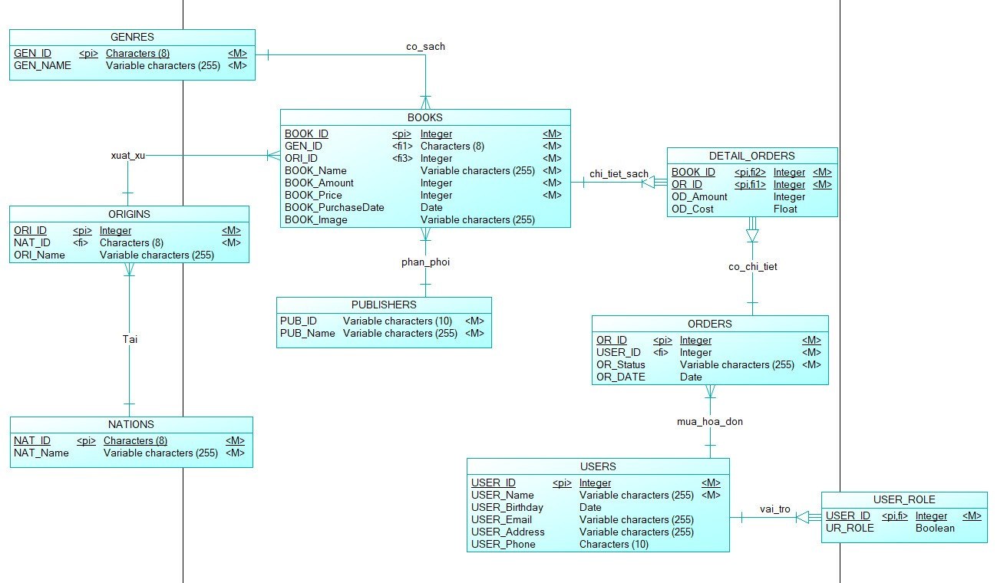

Figure 9. LDM

### PHYSICAL DATA MODEL

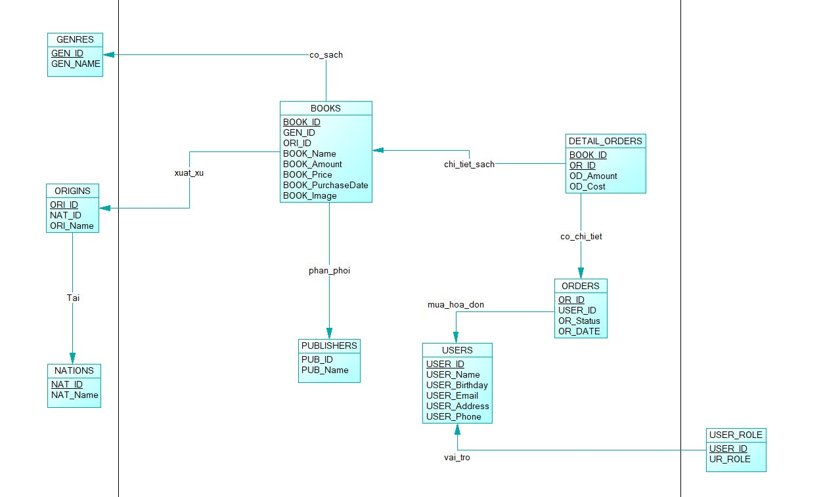

Figure 10. PDM

## DATA DICTIONARY

|  |  |  |
| --- | --- | --- |
| **Entity/Data** | **Type** | **Description** |
| BOOKS | Object | An entity that represents the list of books. |
| BOOK_ID | Integer | The integer that represents the ID of Book. |
| BOOK_Name | Varchar | The string that represents the name of book |
| BOOK_Amount | Integer | The integer that represents the quantity remaining. |
| BOOK_PRICE | Integer | The integer that represents the price of each book |
| BOOK_PurchaseDate | Date | The date that represents the import day of book. |
| BOOK_Image | Varchar | The string that represents the URL of book’s image. |
| GENRES | Object | An entity that represents list type of books. |
| GEN_ID | Char | The string that represents ID of type. |
| GEN_Name | Varchar | The string that represents the type’s name. |
| ORIGINS | Object | An entity that represents list of book’s origin. |
| ORI_ID | integer | The integer that represents the area code of each city. |
| ORI_Name | Varchar | The string that represents the city’s name. |
| NATIONS | Object | An entity that represents list of nation. |
| NAT_ID | Char | The string that represents the ID of nation. |
| NAT_Name | Varchar | The string that represents the name of nation. |
| PUBLISHERS | Object | An entity that represents list of publishers. |
| PUB_ID | Varchar | The string that represents the ID of publisher. |
| PUB_Name | Varchar | The string that represents the publisher’s name. |
| USERS | Object | An entity that represents user’s information. |
| USER_ID | Integer | The integer that represents the ID of each user. |
| USER_Name | Varchar | The string that represents the user’s name. |
| USER_Birthday | Date | The date that represents the birthday of user. |
| USER_Email | Varchar | The string that represents the user’s email. |
| USER_Address | Varchar | The string that represents the address of user. |
| USER_Phone | Char | The string that represents the user’s phone number. |
| USER_ROLE | Object | An entity that represents a user authorization |
| UR_ROLE | Boolean | A value of either 1 or 0. 1 will be represented an administrator’s authorization and 0 will be represented a customer . |
| ORDERS | Object | An entity that represents list of books in user’s cart. |
| OR_ID | Integer | The integer that represents the user's order ID. |
| OR_Status | Varchar | The string that represents the user's purchasing status. |
| OR_DATE | Date | The date that represents the date user ordered the products. |
| DETAIL_ORDERS | Object | An entity that represents the detailed information about the user's order. |
| OD_Amount | Integer | The integer that represents the quantity of products the user purchases. |
| OD_Cost | Float | The float that represents the price of each product with the corresponding quantity. |

## FUNCTIONAL DECOMPOSITION DIAGRAM

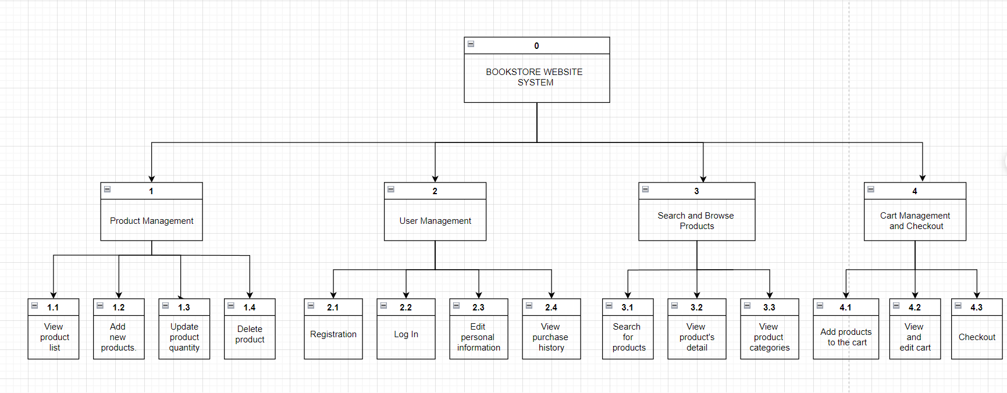

Figure 11. Functional Decomposition Diagram

## DETAIL DESIGN

### Product Management

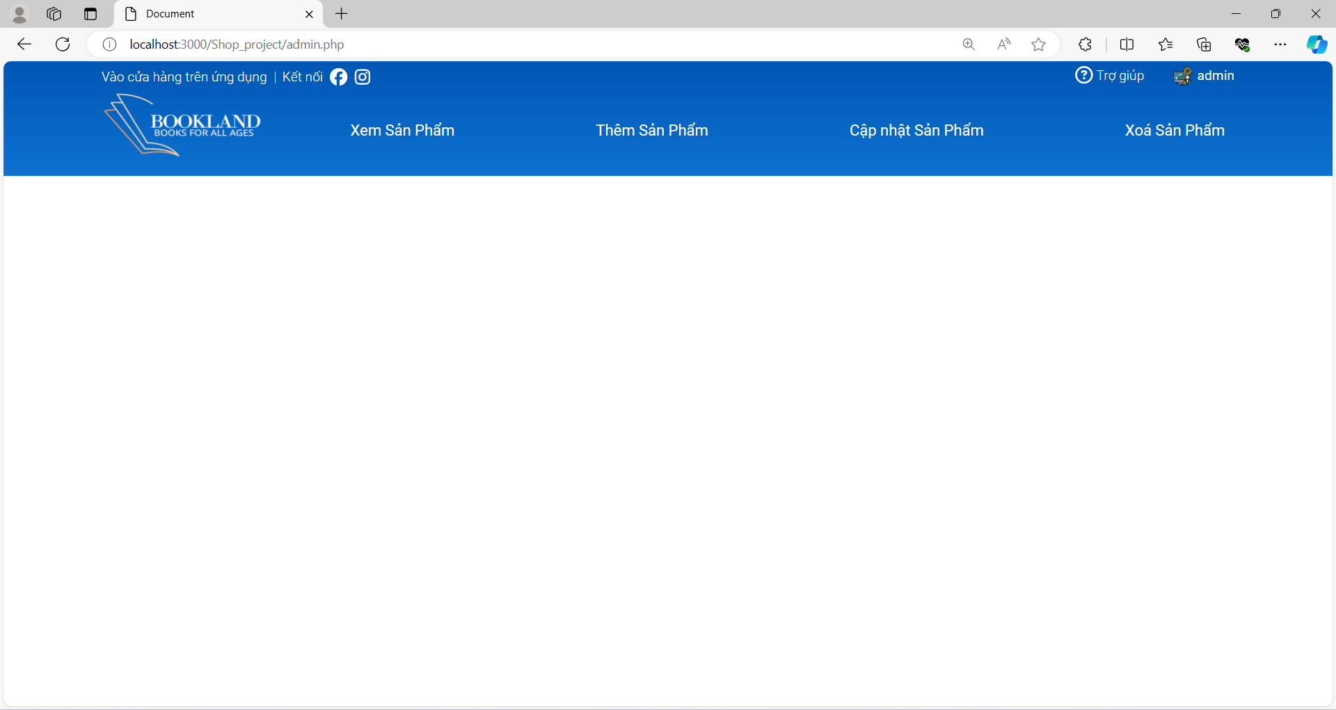

4

3

1

2

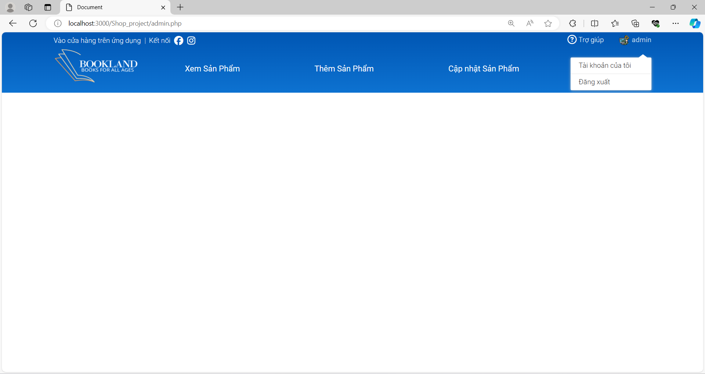

5

Figure 12. Admin Interface

* **Purpose:** This is the admin homepage accompanied by navigation bars, guiding admin users to where they can perform product management functions.
* **The components of interface:**

|  |  |  |  |
| --- | --- | --- | --- |
| **No.** | **Controller Type** | **Default Value** | **Note** |
| 1. | Button | Idle | User can tap the button to move to view product page. |
| 2. | Button | Idle | User can tap the button to move to add product page. |
| 3. | Button | Idle | User can tap the button to move to update product page. |
| 4. | Button | Idle | User can tap the button to move to delete product page. |
| 5. | Button | Idle | User can tap the button to log out. |

* **Data to be used:** All user actions in this interface won’t add, modify, delete, or query from any table or database.

#### View Product List

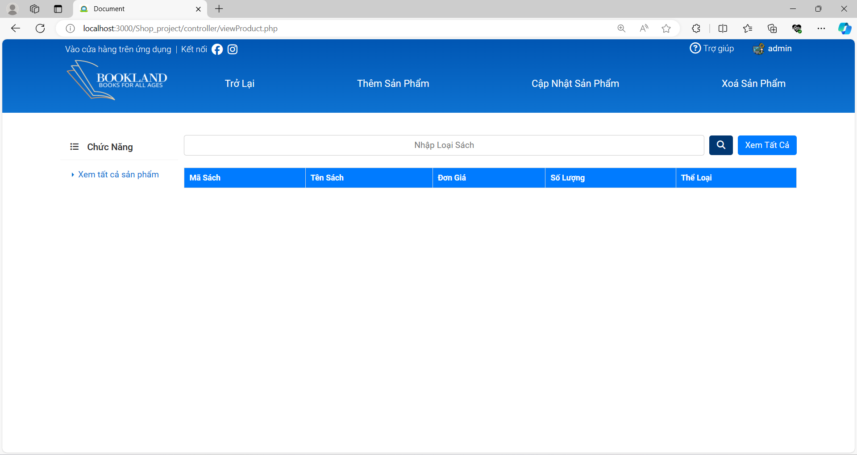

7

6

5

4

3

2

1

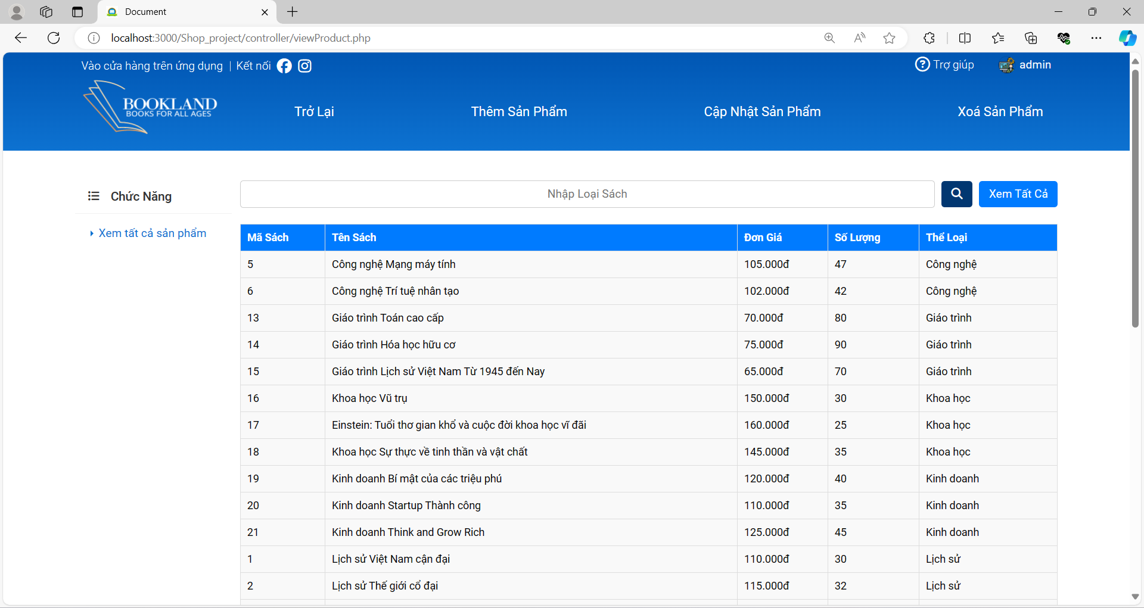

8

Figure 13. View Product Interface

* **Purpose:** On this page, the admin can view detailed information about each type of book in the database. Additionally, the admin can search for books by type of book by entering the type of name into the input field or view all books in the database by clicking on "View All".
* **The components of interface:**

|  |  |  |  |
| --- | --- | --- | --- |
| **No.** | **Controller Type** | **Default Value** | **Note** |
| 1. | Button | Idle | User can tap the button to move back to admin’s homepage . |
| 2. | Button | Idle | User can tap the button to move to add product page. |
| 3. | Button | Idle | User can tap the button to move to update product page. |
| 4. | Button | Idle | User can tap the button to move to delete product page. |
| 5. | Textbox |  | Input field for the type’s name of book. |
| 6. | Button | Idle | User can tap the button to search for books based on category names. |
| 7 | Button | Idle | User can tap the button to view all books in database. |
| 8 | Table |  | The user's search data will then be retrieved and displayed in a table. |

* **Data to be used:** In this interface’s actions, The system will query the data in the database table based on the user's search information and display it on the web page table.

#### Add New Product

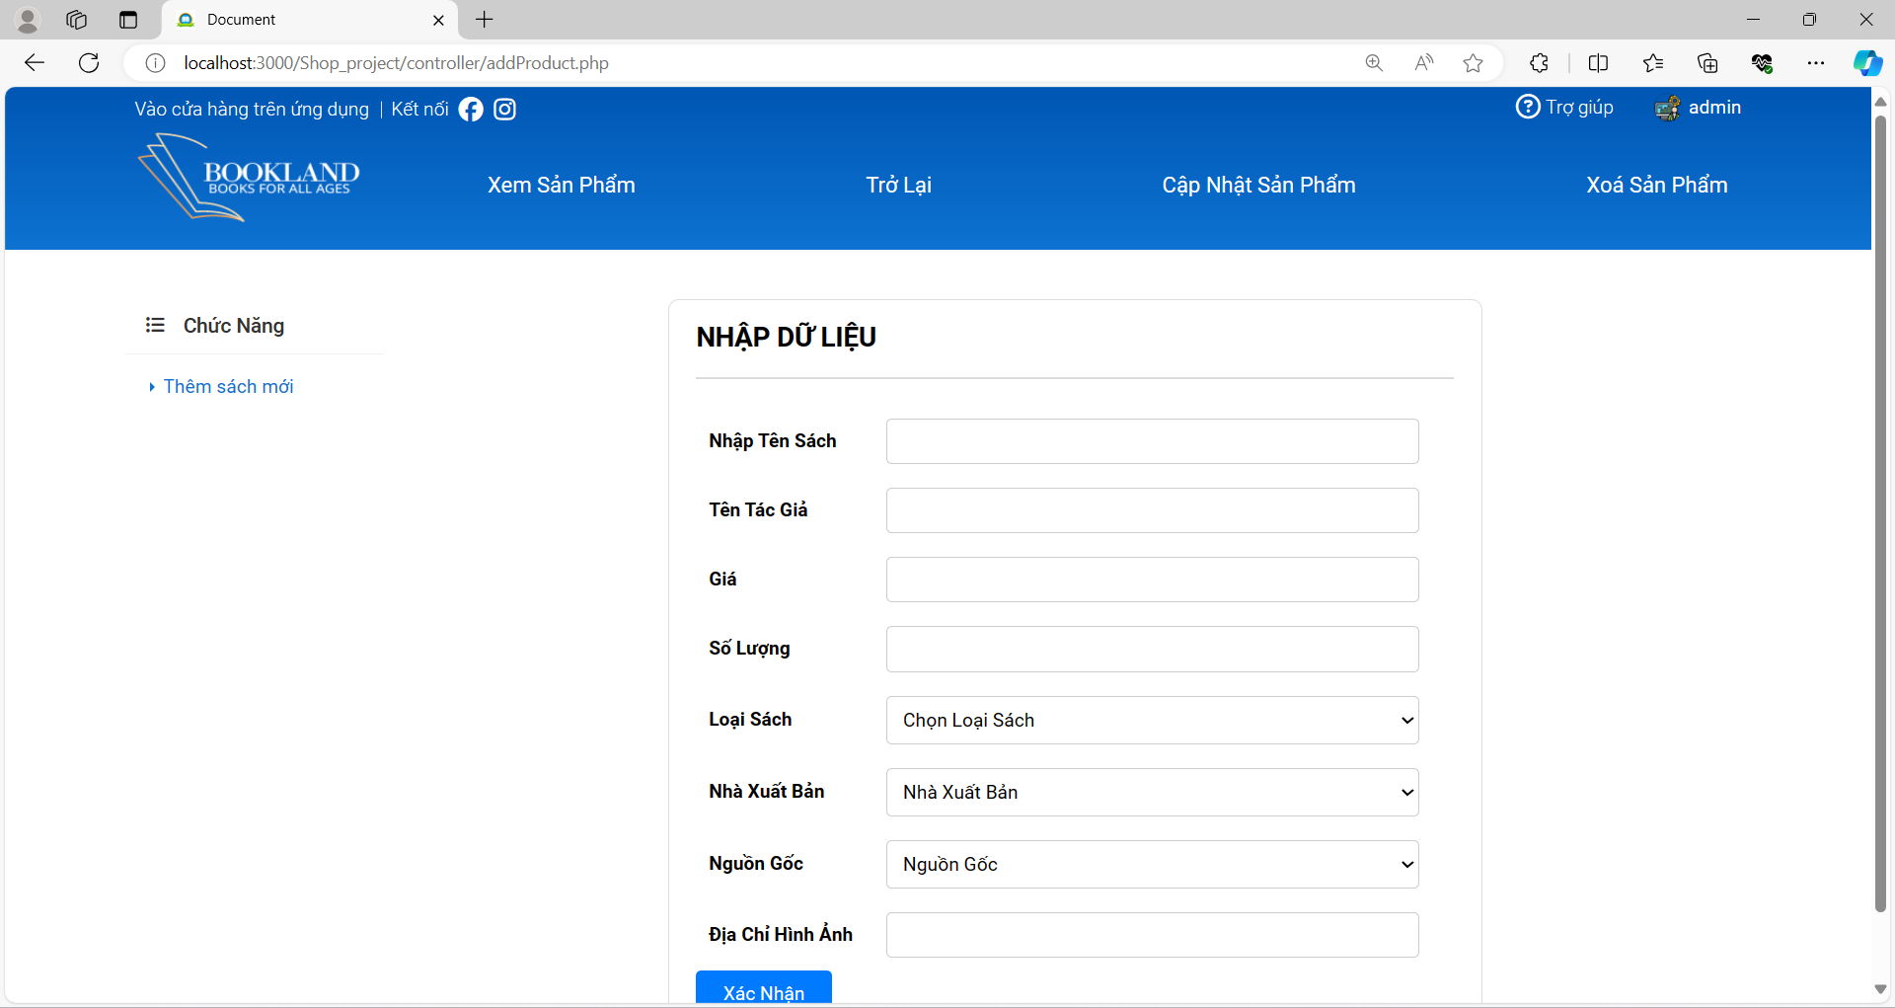

9

8

7

6

5

4

3

2

1

Figure 14. Add Product Interface

* **Purpose:** On this page, the admin will need to enter all relevant information about the book such as name, quantity, category, etc. After entering all the necessary information, the book will be added to the database.
* **The components of interface:**

|  |  |  |  |
| --- | --- | --- | --- |
| **No.** | **Controller Type** | **Default Value** | **Note** |
| 1. | Input |  | Input field for the name of book. |
| 2. | Input |  | Input field for the author’s name. |
| 3. | Input |  | Input field for the price. |
| 4. | Input |  | Input field for the quantity. |
| 5. | Select | TypeName | Select type of book. |
| 6. | Select | Publisher | Select Information about the publisher of the book. |
| 7 | Select | Origin | Select the origin of the book. |
| 8 | Input |  | Choose an image for the book. |

* **Data to be used:** In this interface’s actions, the system will take the information provided by the user and add the relevant details about the book to the database.

#### Update Product Quantity

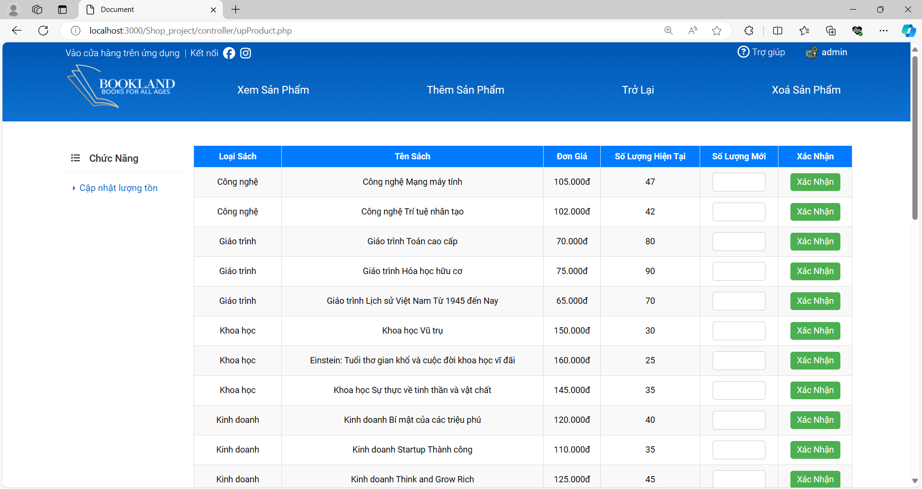

2

1

Figure 15.Update Quantity Interface

* **Purpose:** On this page, the admin can update the inventory quantity of the product.
* **The components of interface:**

|  |  |  |  |
| --- | --- | --- | --- |
| **No.** | **Controller Type** | **Default Value** | **Note** |
| 1. | Input |  | Input field for user to enter the new quantity of book. |
| 2. | Button | Idle | User can tap the button to update new quantity for book. |

* **Data to be used:** In this interface’s actions, the system will take the new quantity by the user then update the new quantity in the database.

#### Delete Product

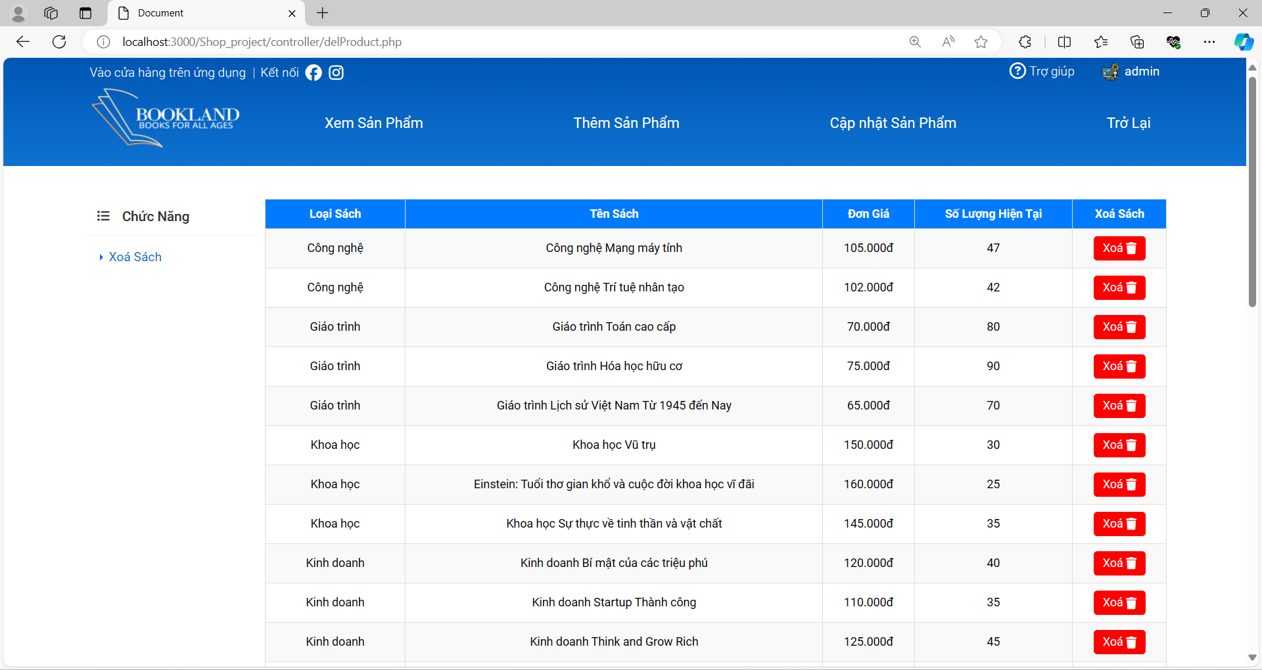

1

Figure 16. Delete Product Interface

* **Purpose:** On this page, the admin can delete the product from the database.
* **The components of interface:**

|  |  |  |  |
| --- | --- | --- | --- |
| **No.** | **Controller Type** | **Default Value** | **Note** |
| 1. | Button | Idle | User can tap the button to remove product from database. |

* **Data to be used:** In this interface’s actions, the system will delete product from the database.

### User Management

* Before Login

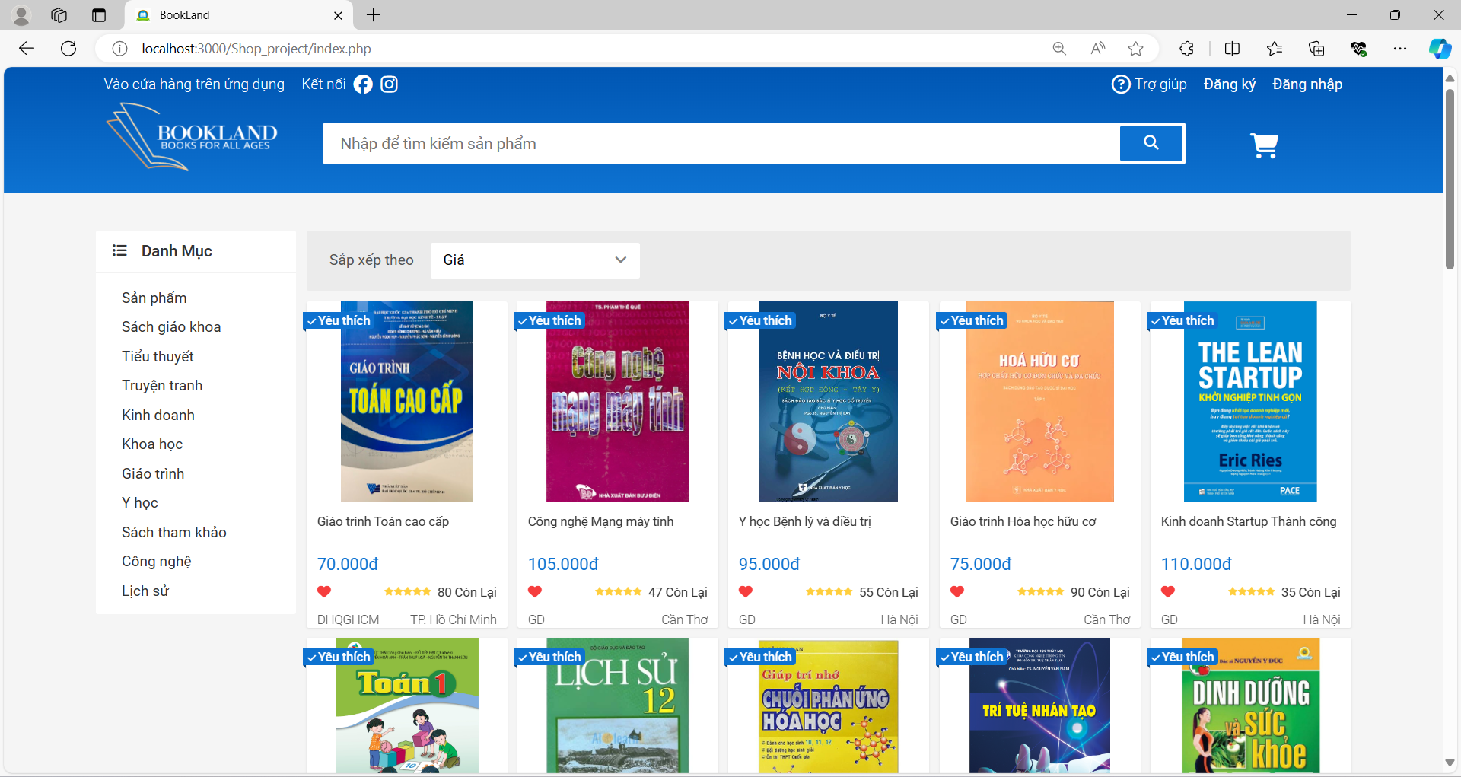

4

8

7

6

5

3

2

Figure 17. Before Login Interface

* + **Purpose:** This is index page, where guest will access before logging in. They can view a list of products available for sale on the shop. Additionally, they can search for books and view details about each book. If users want to make a purchase, they can register an account to log in to the website.
  + **The components of interface:**

|  |  |  |  |
| --- | --- | --- | --- |
| **No.** | **Controller Type** | **Default Value** | **Note** |
| 1. | Button | Idle | User can tap the button to show a registration’s interface then create an account |
| 2. | Button | Idle | User can tap the button to show a Login’s interface to login to the website if they have already created an account |
| 3. | Input |  | An input field that user can enter a name of books for searching |
| 4. | Button | Idle | User can tap the button to find a book after entering a book’s name |
| 5. | List of Button | Idle | User can tap the button to filter books by category. |
| 6. | Filter |  | Users can select a filter to sort books by price. |
| 7. | Button | Idle | User can tap the button to view the book’s detail |
| 8. | Label |  | The label that represents the remaining quantity of that book. |

* + **Data to be used:** In this interface’s actions, the system will use query to show the products and sort products according to user preference.
* After Login

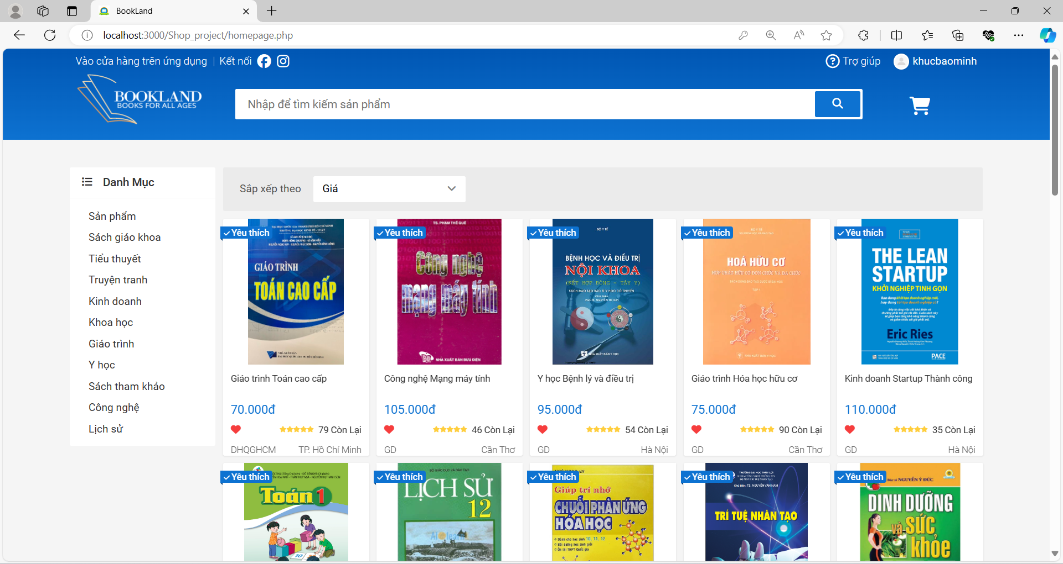

2

1

Figure 18. After Login Interface

* + **Purpose:** This is a user’s homepage, where customers will access after logging in. Customers can view a list of products available for sale on the shop. Additionally, Customers also can search for books and view details about each book. Moreover, they can add the book they love to cart and view their cart.
  + **The components of interface:**

|  |  |  |  |
| --- | --- | --- | --- |
| **No.** | **Controller Type** | **Default Value** | **Note** |
| 1. | Label |  | The label that represents the username of customer. |
| 2. | Button | Idle | User can tap the button to view the cart’s information |

* + **Data to be used:** In this interface’s actions, the system will use query to show the products, sort products according to user preference and the cart’s information.

#### Registration

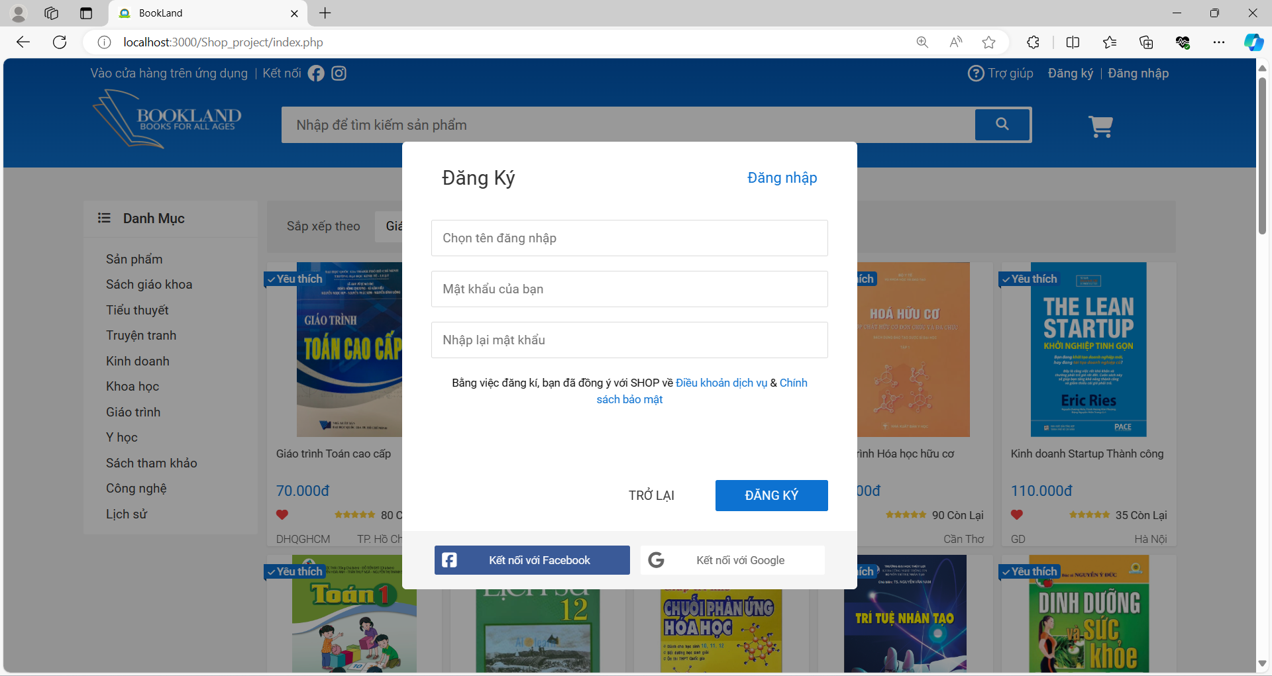

2

6

5

4

3

1

Figure 19. Register Interface

* **Purpose:** The registration’s form, where guest or customer can create an account.
* **The components of interface:**

|  |  |  |  |
| --- | --- | --- | --- |
| **No.** | **Controller Type** | **Default Value** | **Note** |
| 1. | Button | Idle | User can tap the button to go to login form |
| 2. | Input |  | An input field that user can enter their username |
| 3. | Input |  | An input field that user can enter their password |
| 4. | Input |  | An input field that user verifies their password |
| 5. | Button | Idle | User can tap the button to turn back to index |
| 6. | Button | Idle | User can tap the button to create an account |

* **Data to be used:** In this interface’s actions, the system will add account’s information to database.

#### Log In

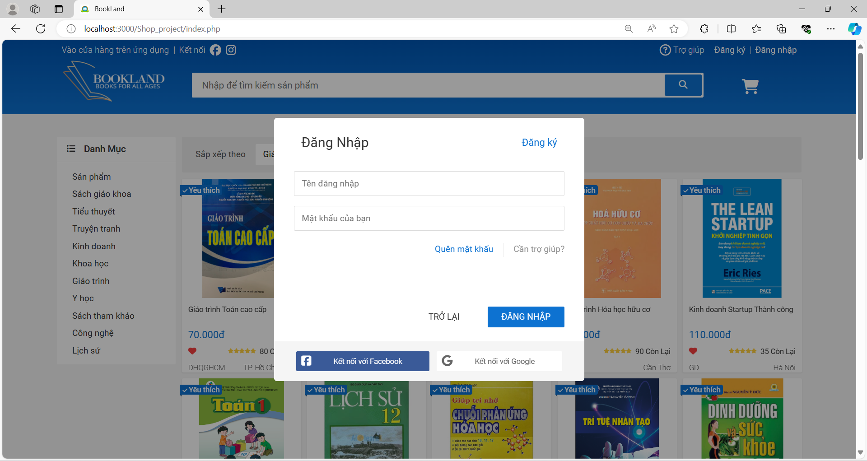

5

4

3

2

1

Figure 20. Login Interface

* **Purpose:** The Login’s form, where customer can sign in to website or creating a new account.
* **The components of interface:**

|  |  |  |  |
| --- | --- | --- | --- |
| **No.** | **Controller Type** | **Default Value** | **Note** |
| 1. | Button | Idle | User can tap the button to turn back to registration’s form. |
| 2. | Input |  | An input field that user can enter their username |
| 3. | Input |  | An input field that user can enter their password |
| 4. | Button | Idle | User can tap the button to turn back to index |
| 5. | Button | Idle | User can tap the button to create an account |

* **Data to be used:** In this interface’s actions, the system will use query to verify the username and password of customer. If it’s existed, navigate customer to their homepage. If it’s not, send an error and request customer try again.

#### Update and View Personal Information

##### User Functional Navigation

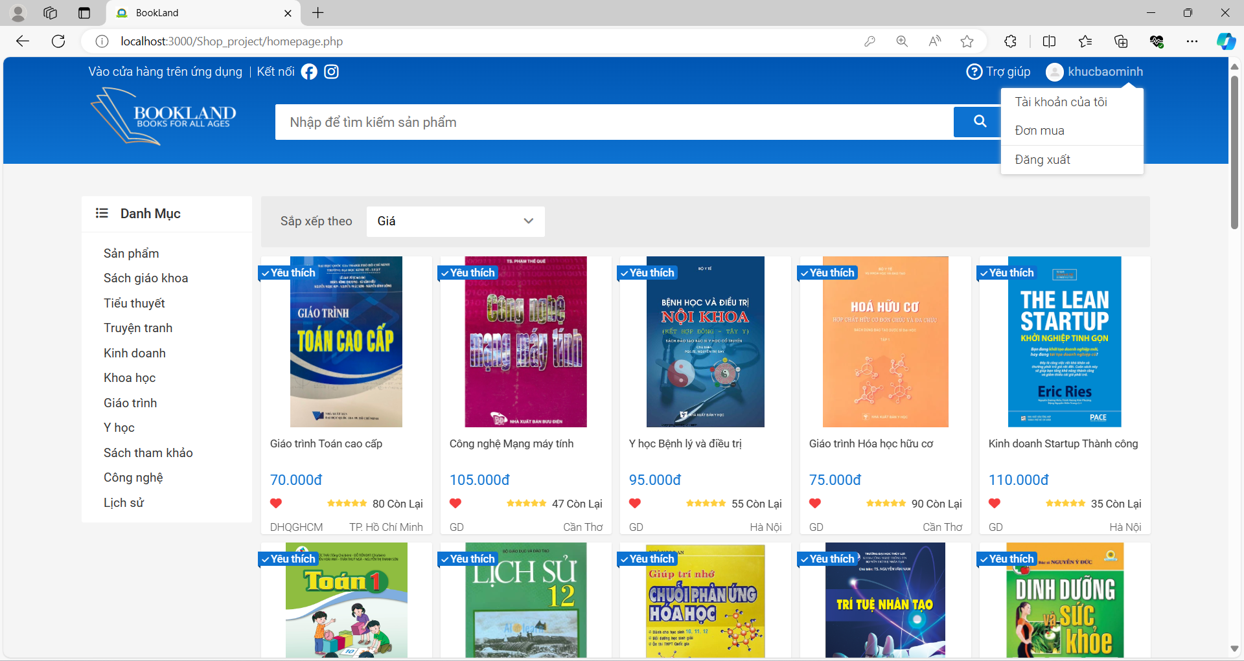

3

2

1

Figure 21. Navigation Interface

* **Purpose:** The Navigations that can navigate user to personal page or their cart.
* **The components of interface:**

|  |  |  |  |
| --- | --- | --- | --- |
| **No.** | **Controller Type** | **Default Value** | **Note** |
| 1. | Button | Idle | User can tap the button to navigate to personal’s page |
| 2. | Button | Idle | User can tap the button to navigate to their cart |
| 3. | Button | Idle | User can tap the button to logout from website |

* **Data to be used:** All user actions in this interface won’t add, modify, delete, or query from any table or database.

##### Update Personal Information

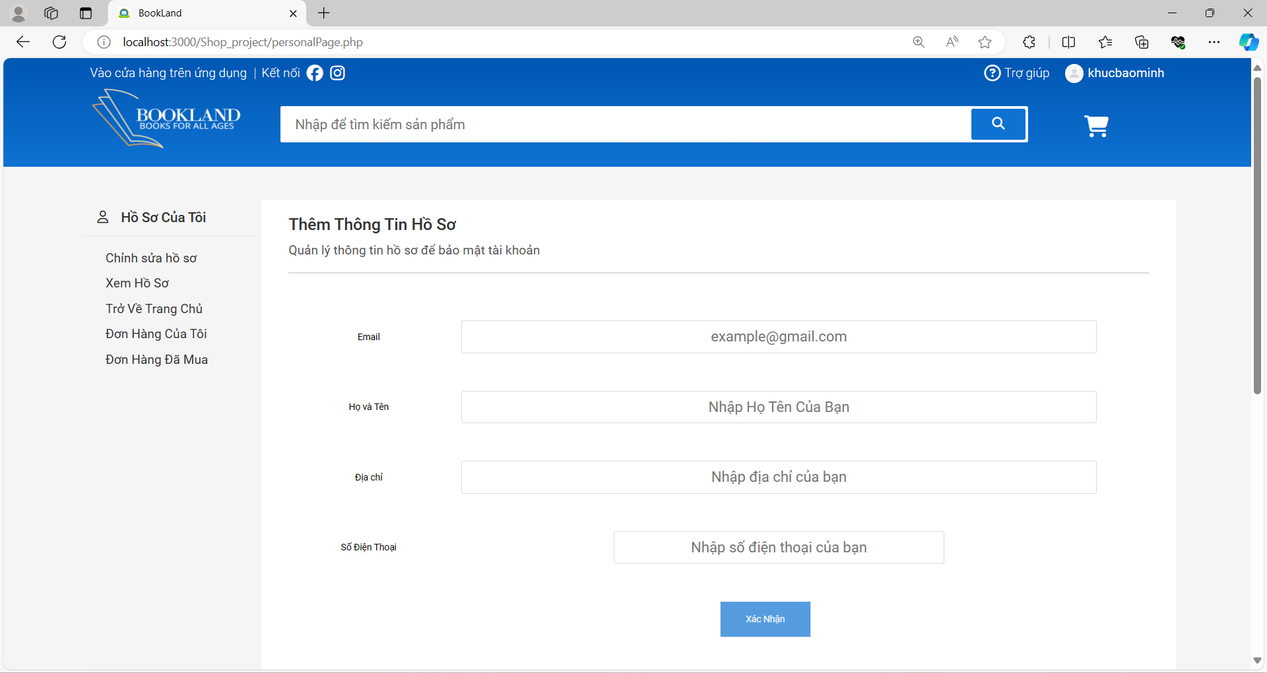

5

4

3

2

1

Figure 22. Login Interface

* **Purpose:** The personal’s interface, that user can insert or update their information.
* **The components of interface:**

|  |  |  |  |
| --- | --- | --- | --- |
| **No.** | **Controller Type** | **Default Value** | **Note** |
| 1. | Input |  | An input field that user can enter their email address. |
| 2. | Input |  | An input field that user can enter their full name. |
| 3. | Input |  | An input field that user can enter their home’s address. |
| 4. | Input |  | An input field that user can enter their email address. |
| 5. | Button | Idle | User can tap the button for entering their information |

* **Data to be used:** In this interface, system will add or modify the user’s information.

##### View Personal Information

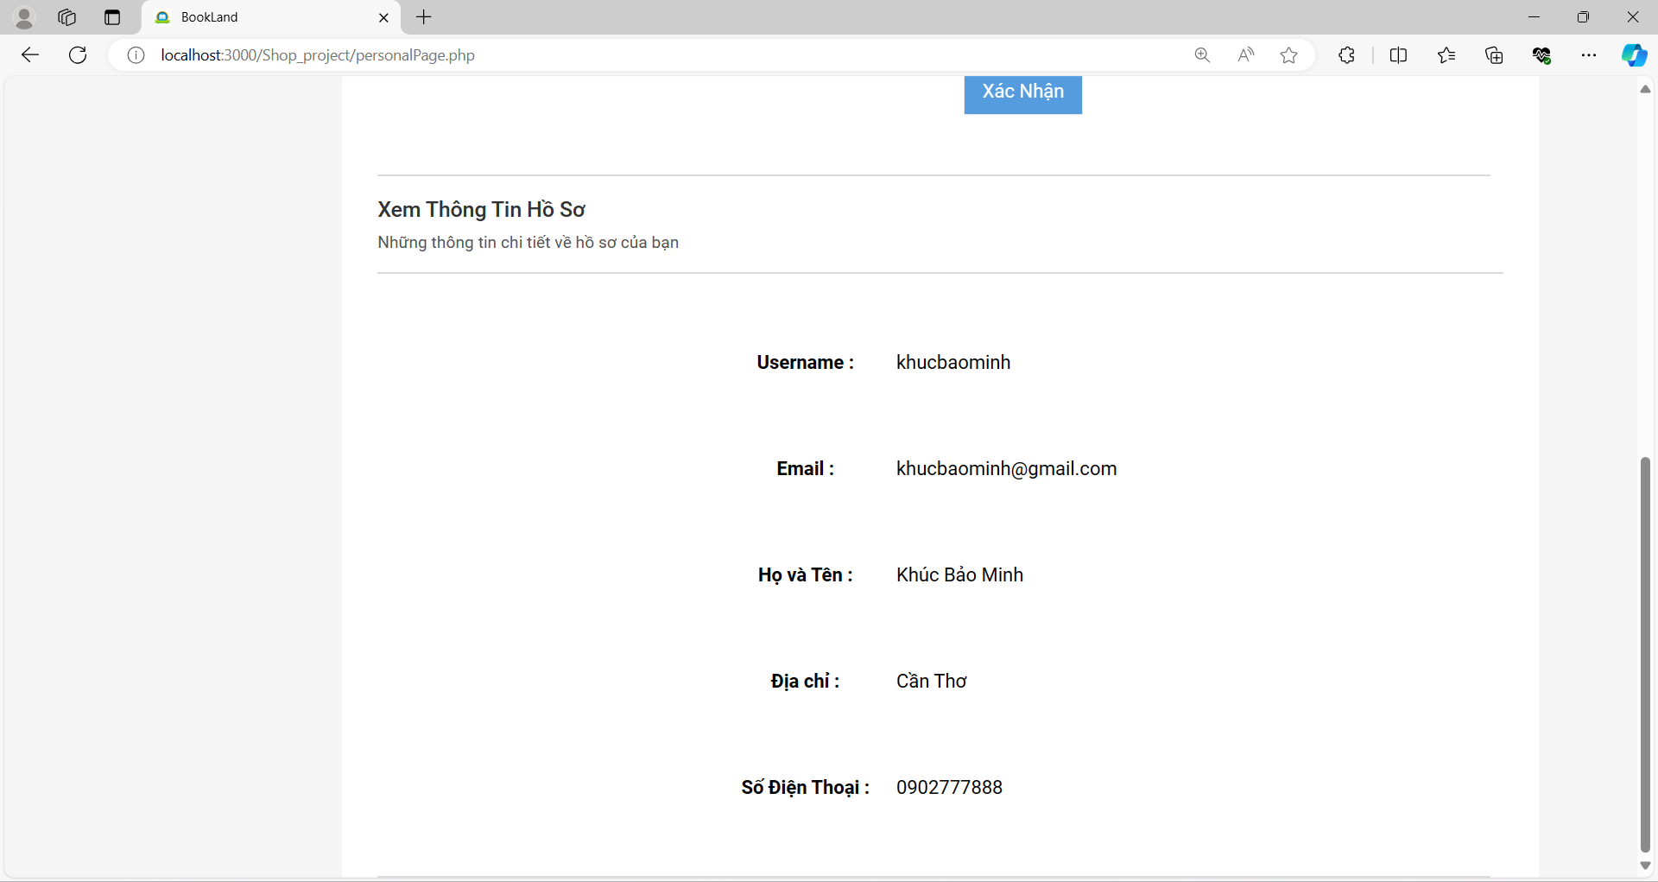

5

4

3

2

1

Figure 23. Login Interface

* **Purpose:** The personal’s interface, that user can view their information.
* **The components of interface:**

|  |  |  |  |
| --- | --- | --- | --- |
| **No.** | **Controller Type** | **Default Value** | **Note** |
| 1. | Label |  | The label that represents the username |
| 2. | Label |  | The label that represents the email address |
| 3. | Label |  | The label that represents the full name |
| 4. | Label |  | The label that represents the address |
| 5. | Label |  | The label that represents the phone number |

* **Data to be used:** All user actions in this interface won’t add, modify, delete, or query from any table or database.

#### View Purchase History

* Before proceeding to check out the product,

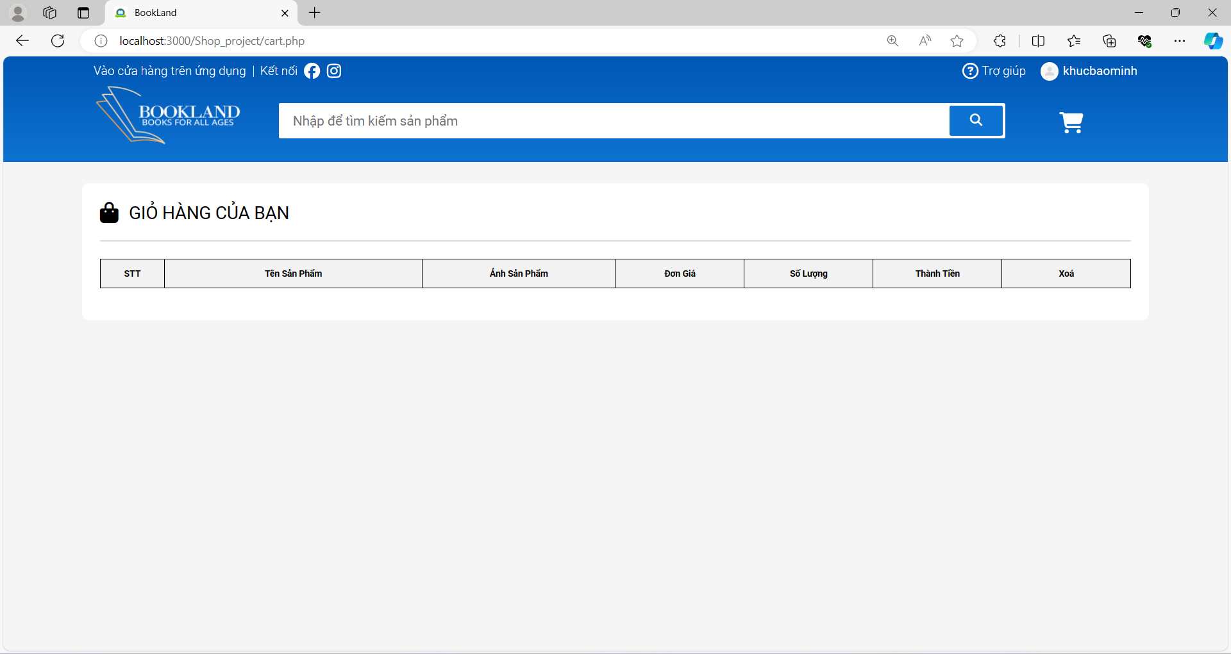

Figure 24. View Purchase History Interface (Before Payment)

* After proceeding to check out the product,

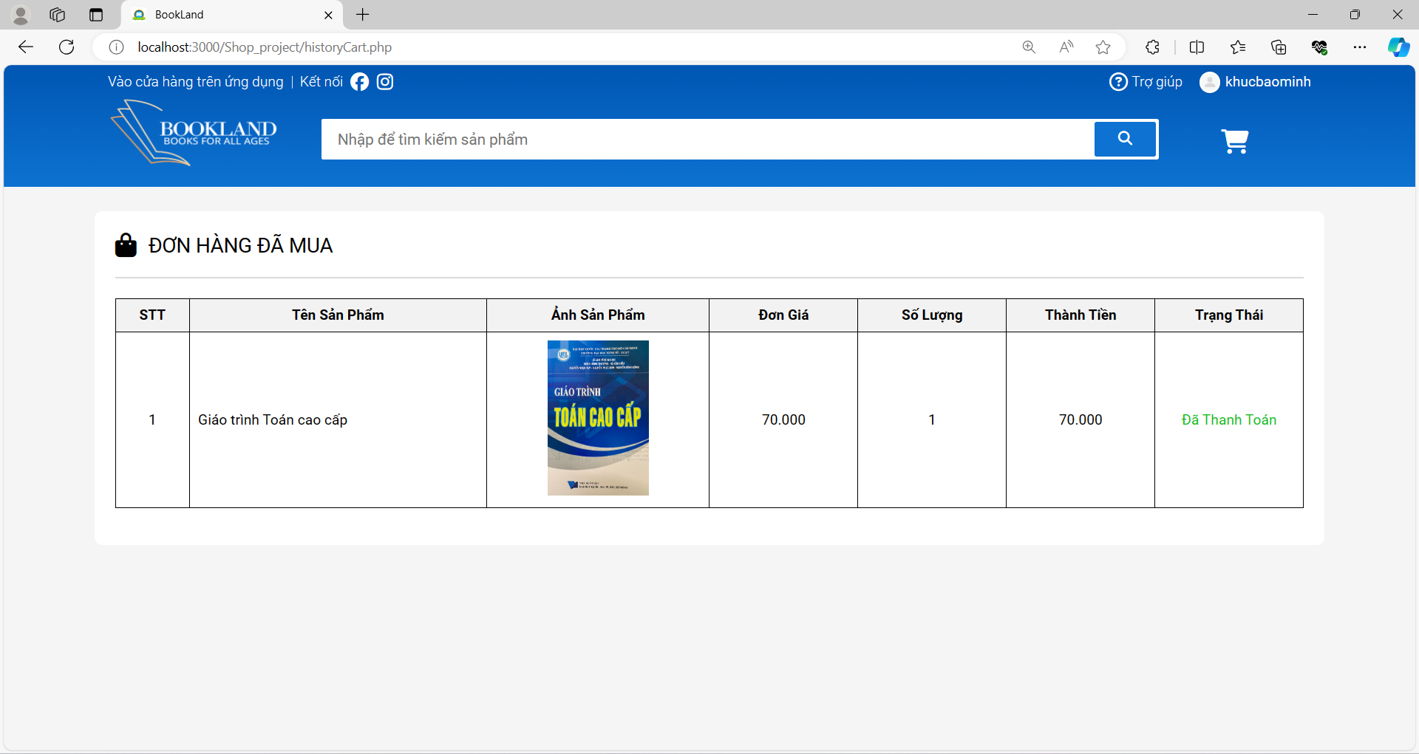

4

6

5

3

1

2

* Figure 25. View Purchase History Interface (After Payment)
  + **Purpose:** The personal’s history purchase interface, that user can view their purchased products.
  + **The components of interface:**

|  |  |  |  |
| --- | --- | --- | --- |
| **No.** | **Controller Type** | **Default Value** | **Note** |
| 1. | Label |  | The label that represents the book’s name |
| 2. | Label |  | The label that represents the image of book |
| 3. | Label |  | The label that represents the book’s price |
| 4. | Label |  | The label that represents the amount purchased |
| 5. | Label |  | The label that represents the cost |
| 6. | Label |  | The label that represents the status |

* + **Data to be used:** All user actions in this interface won’t add, modify, delete, or query from any table or database.

### Search and Browse Products

#### Search for Products

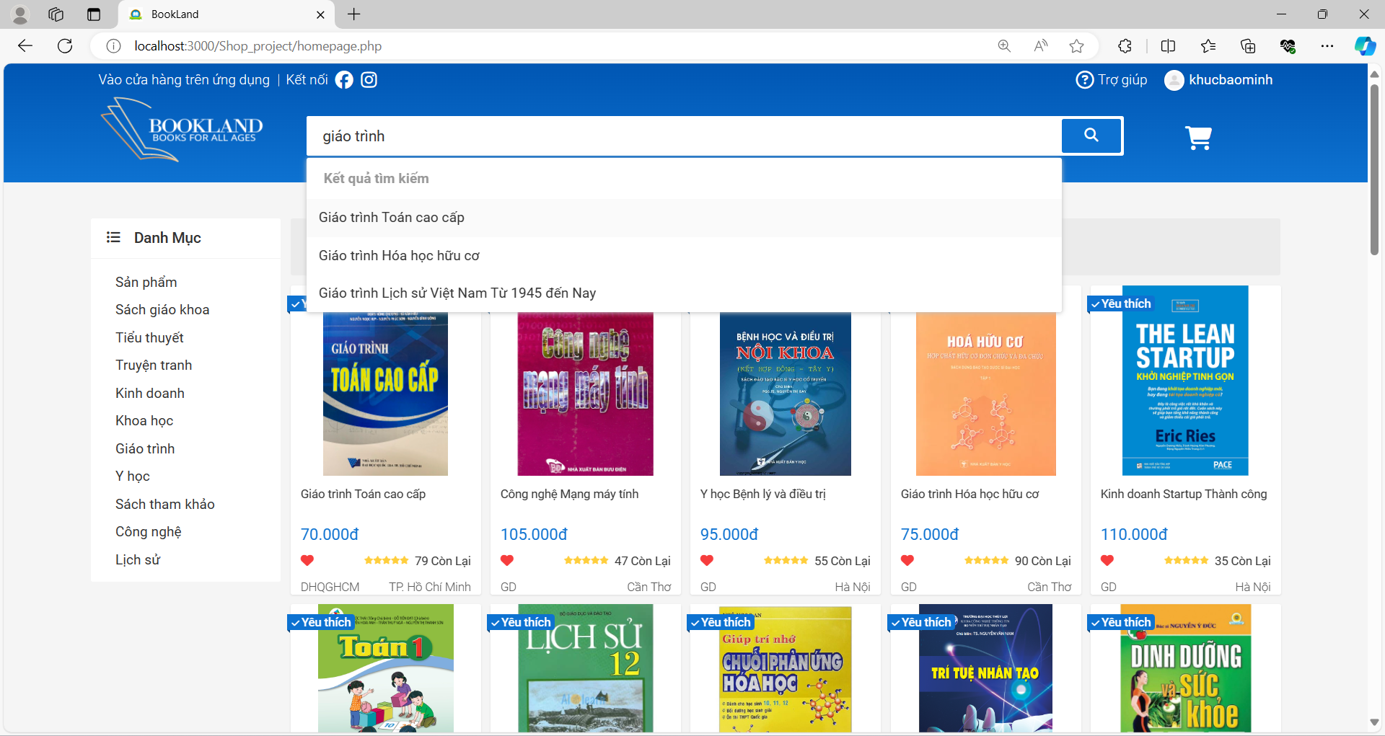

3

2

1

Figure 26. search Interface

* **Purpose:** The interface, that user enter the book’s name for viewing the detail of that book or searching books on home page or index (before login).
* **The components of interface:**

|  |  |  |  |
| --- | --- | --- | --- |
| **No.** | **Controller Type** | **Default Value** | **Note** |
| 1. | Input |  | An input field that user enters book’s name |
| 2. | Button | Idle | User can tap the button for searching the related book |
| 3. | Button | Idle | User can tap the button to view detail book |

* **Data to be used:** In this interface, system will query book information and display it on the user interface.

#### View Product Detail

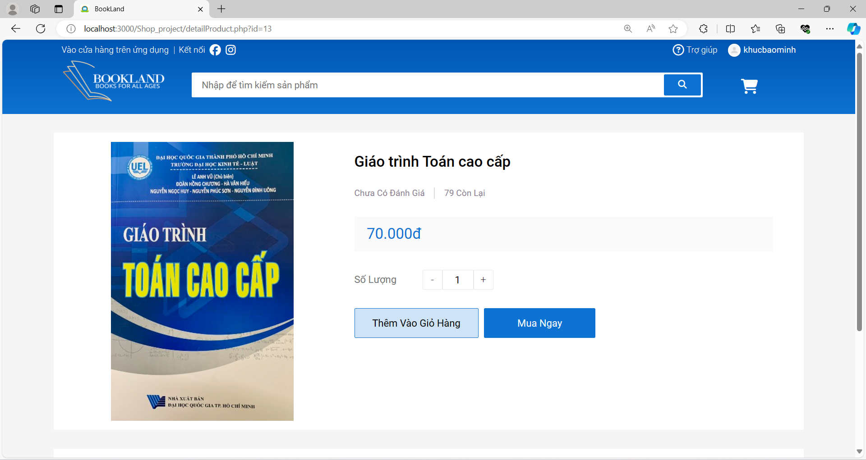

7

6

3

2

5

4

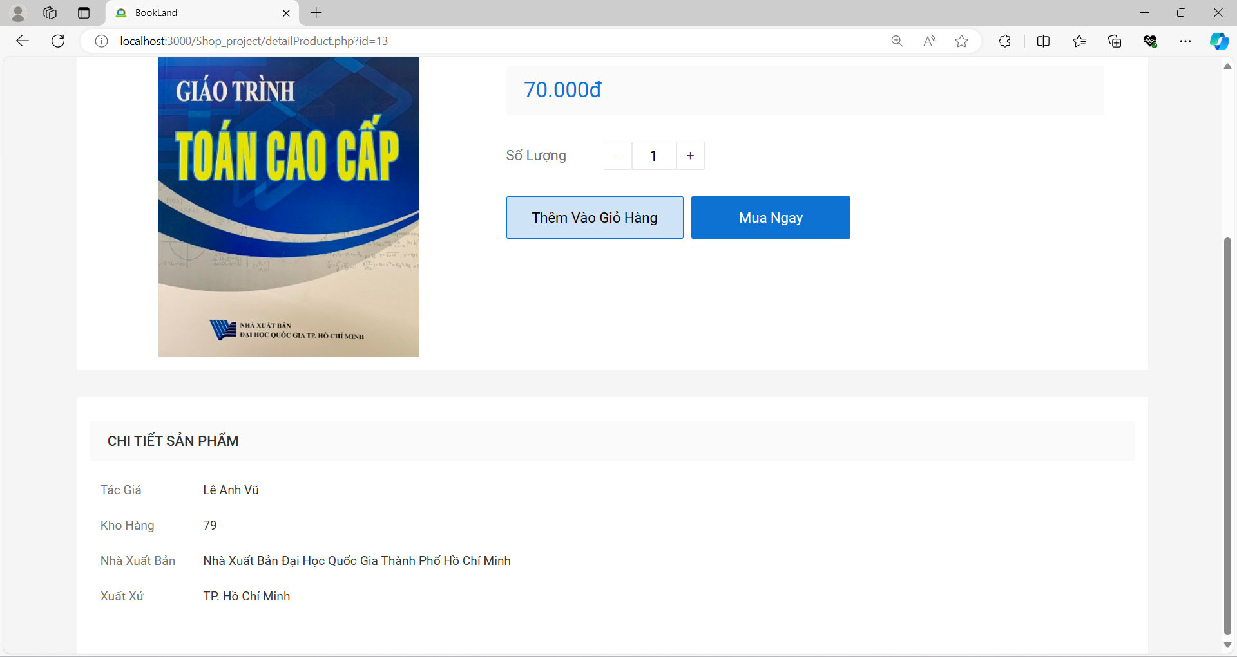 Figure 27. Detail Product Interface

11

100

9

8

* **Purpose:** This interface will show detailed information about each book for the user. Furthermore, user also possible to choose amount of book then add this book to cart.
* **The components of interface:**

|  |  |  |  |
| --- | --- | --- | --- |
| **No.** | **Controller Type** | **Default Value** | **Note** |
| 1. | Label |  | The label that represents the book name |
| 2. | Label |  | The label that represents the book’s price |
| 3. | Input |  | An input field that stores amount of book user want to buy |
| 4. | Button | Idle | User can tap the button for decreasing amount |
| 5. | Button | Idle | User can tap the button for increasing amount |
| 6. | Button | Idle | User can tap the button for adding book to cart |
| 7. | Button | Idle | User can tap the button for going to their cart |
| 8. | Label |  | The label that represents the author’s name |
| 9. | Label |  | The label that represents the inventory quantity |
| 10. | Label |  | The label that represents the publisher of this book |
| 11. | Label |  | The label that represents the origin of this book |

* **Data to be used:** In this action interfaces, user will choose the book’s amount then add them to cart.

#### View Product Categories

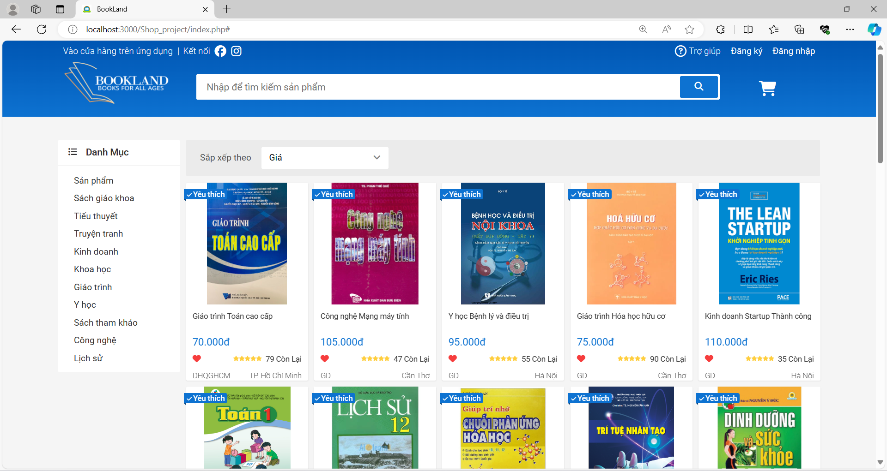

Figure 28. Categories Interface (Before Login)

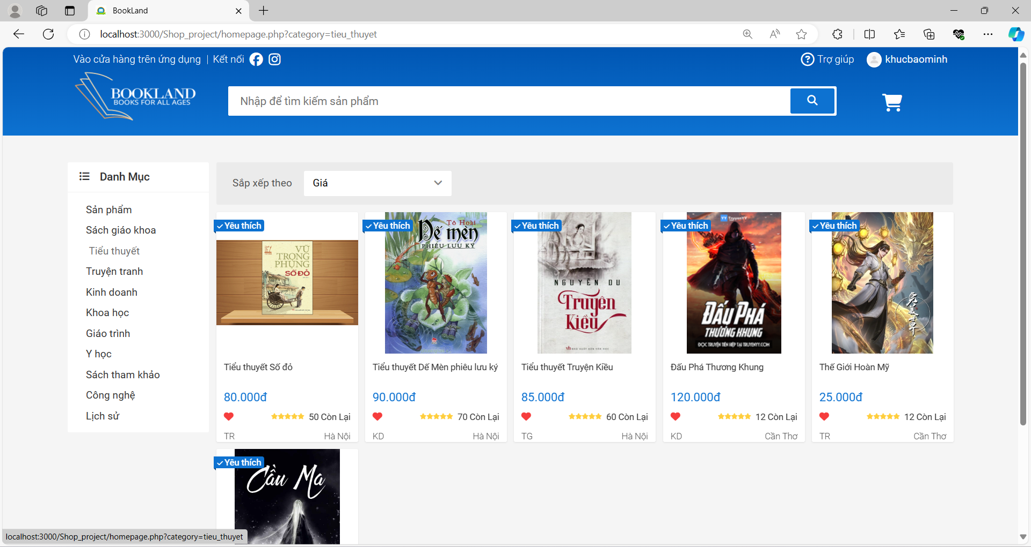

Figure 29. Categories Interface (After Login)

* **Purpose:** This interface will display a list of products that users can purchase. Users can filter the products by category or price.
* **The components of interface:** None
* **Data to be used:** In this action interfaces, system will listen the “click” event of user then query books according to the user's preferences.

### Cart Management and Check Out

#### Add to Cart

* Before adding any products to cart

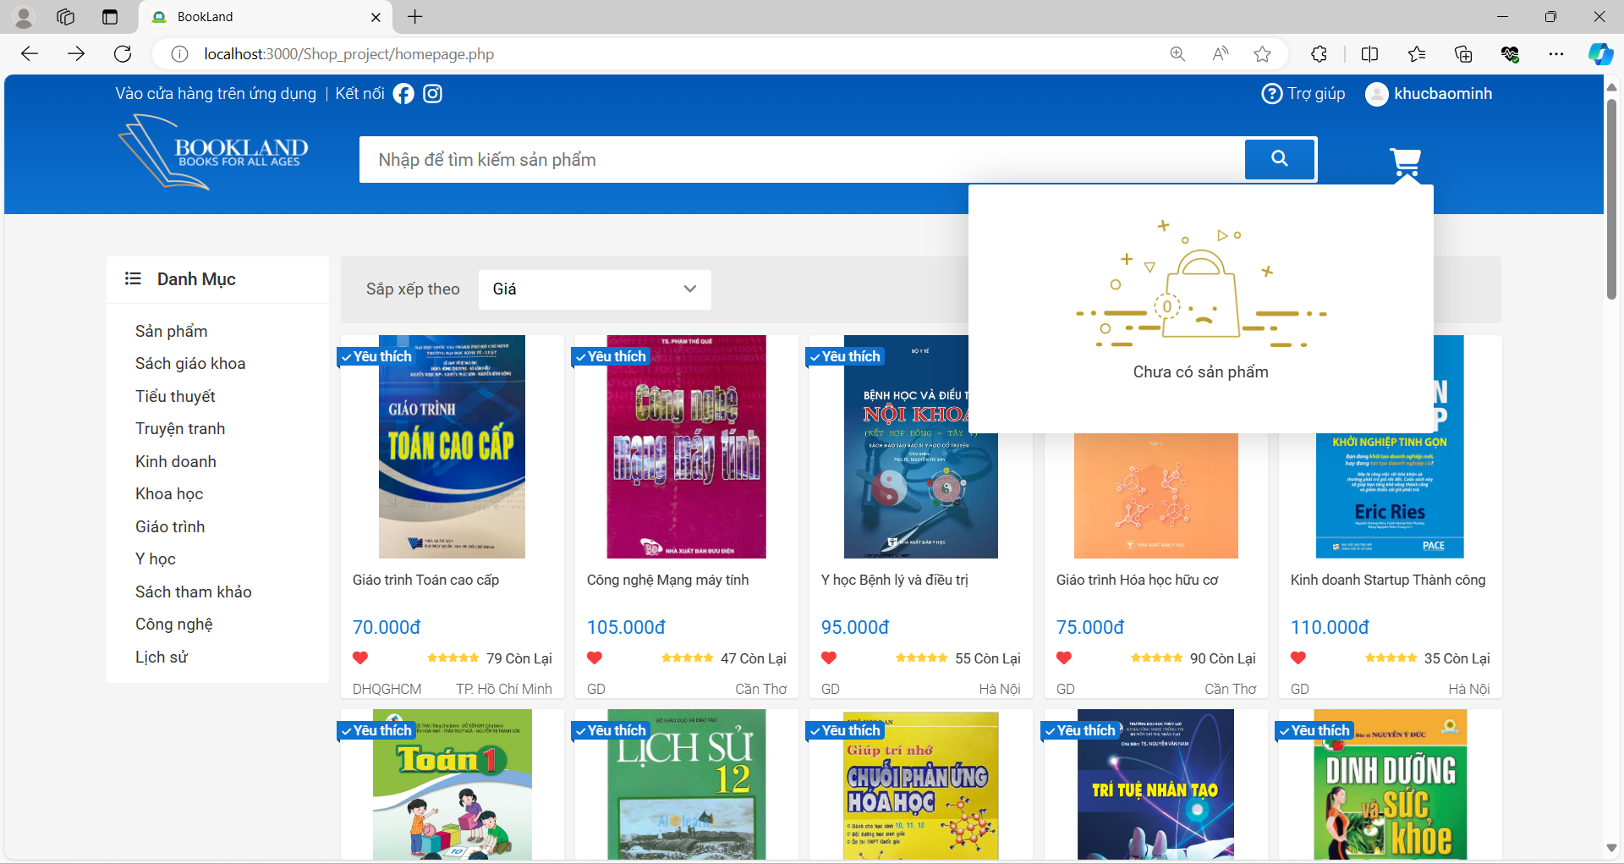

Figure 30. Minicart interface (No Product)

* + **Purpose:** This interface will display to the user if the cart is empty.
  + **The components of interface:** None
  + **Data to be used:** All user actions in this interface won’t add, modify, delete, or query from any table or database.

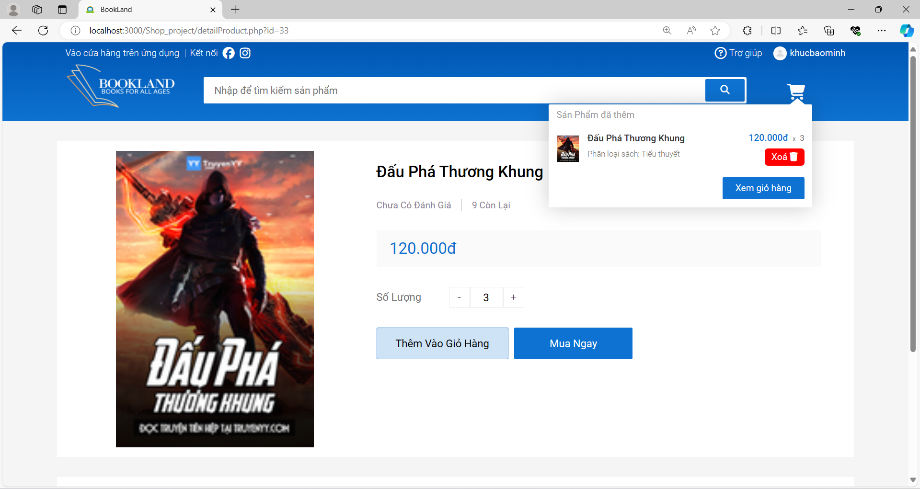

2

1

Figure 31. Minicart interface (Have Product)

* + **Purpose:** This interface will display to the user if the cart is empty.
  + **The components of interface:**

|  |  |  |  |
| --- | --- | --- | --- |
| **No.** | **Controller Type** | **Default Value** | **Note** |
| 1. | Button | Idle | User can tap the button for removing book out the cart |
| 2. | Button | Idle | User can tap the button to navigate to cart |

* + **Data to be used:** User actions in this interface will delete book out the cart.

#### View And Edit Cart

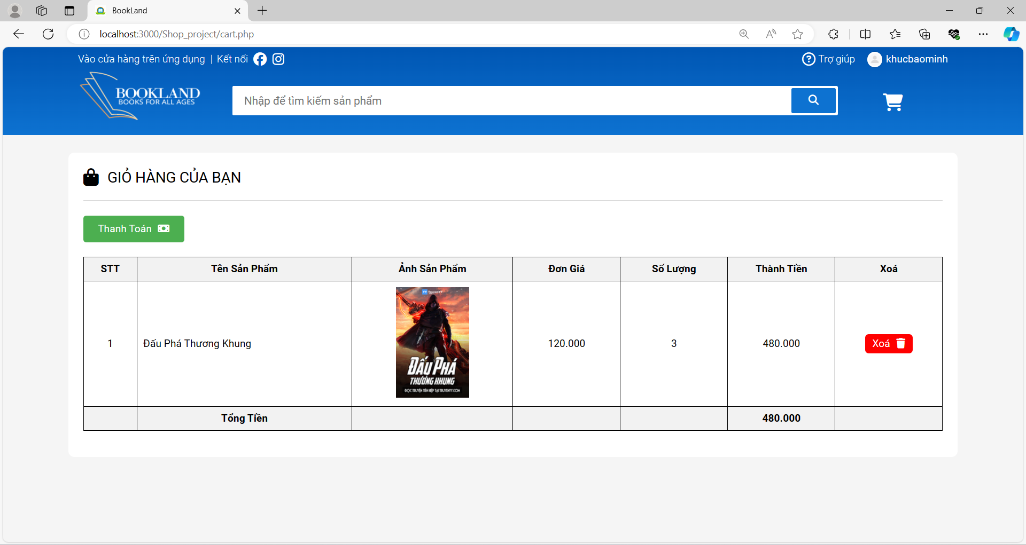

2

1

Figure 32. Cart interface

* **Purpose:** This interface will show detailed information about each book for the user. Furthermore, user also possible to choose amount of book then add this book to cart.
* **The components of interface:**

|  |  |  |  |
| --- | --- | --- | --- |
| **No.** | **Controller Type** | **Default Value** | **Note** |
| 1. | Label |  | The label that represents the total value of the order |
| 2. | Button | Idle | User can tap the button to delete this product from the cart |

* **Data to be used:** In this action interfaces, user will choose the book which they don’t want to buy then remove them out from cart, and system query the book’s information to display cost and total cost of the order.

#### Check Out

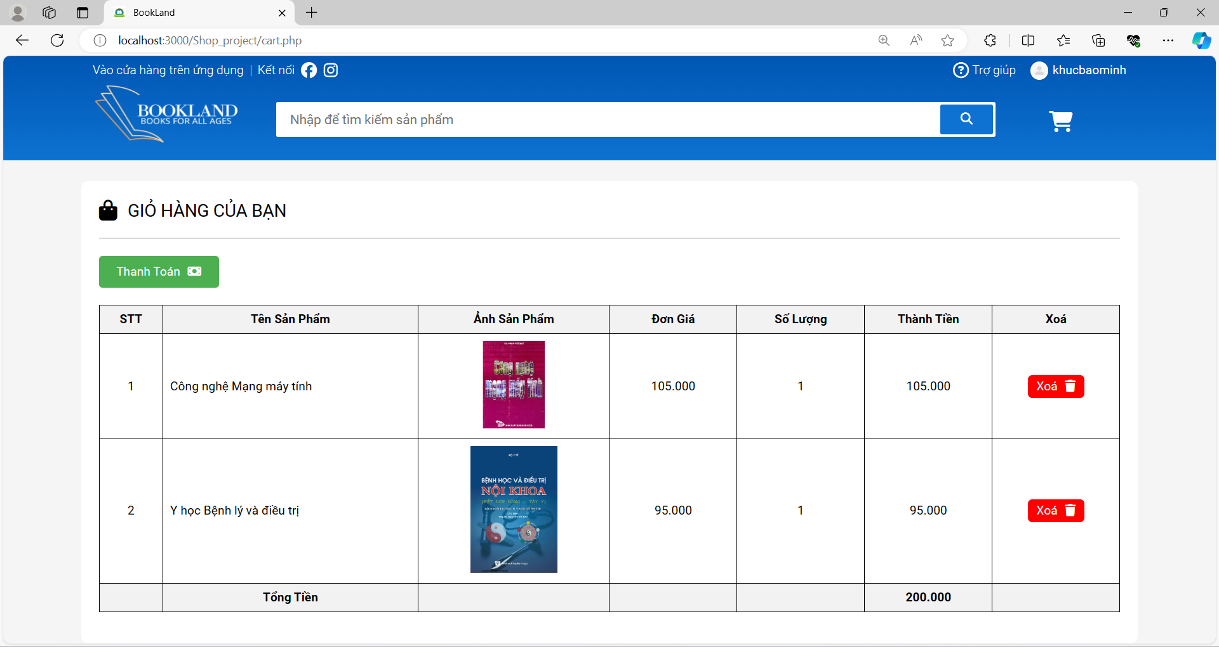

1

Figure 33. Payment

* **Purpose:** In this interface user can pay for their orders.
* **The components of interface:**

|  |  |  |  |
| --- | --- | --- | --- |
| **No.** | **Controller Type** | **Default Value** | **Note** |
| 1. | Button | Idle | User can tap the button for payment |

* **Data to be used:** In this action interfaces, system will modify the status of book in cart.

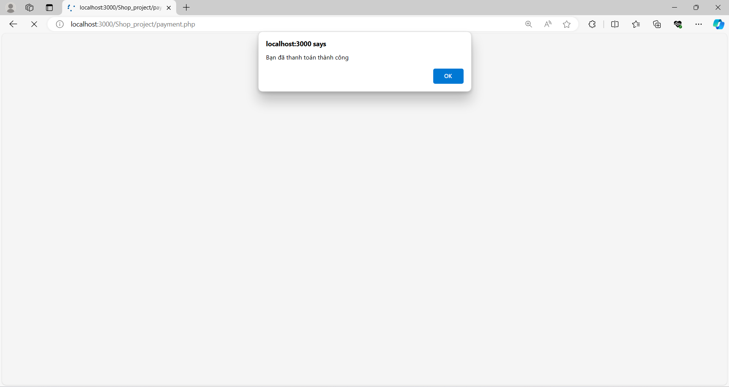

Figure 34. After Payment

* **Purpose:** An alert box notification of successful payment.
* **The components of interface:** None
* **Data to be used:** All user actions in this interface won’t add, modify, delete, or query from any table or database.

# IV. CONCLUSION

During the development of our bookstore website, we have created a flexible and user-friendly management system to help customers easily search for and purchase books online. By providing features such as search, filtering, and ordering, we have optimized the shopping experience for users.

We have integrated features for managing books, orders, and customers, making it easy for the store to manage inventory, process orders, and interact with customers efficiently.

Our website can also be expanded and customized to fit the specific requirements of the bookstore. We hope that this website will help your store grow and expand its online market.